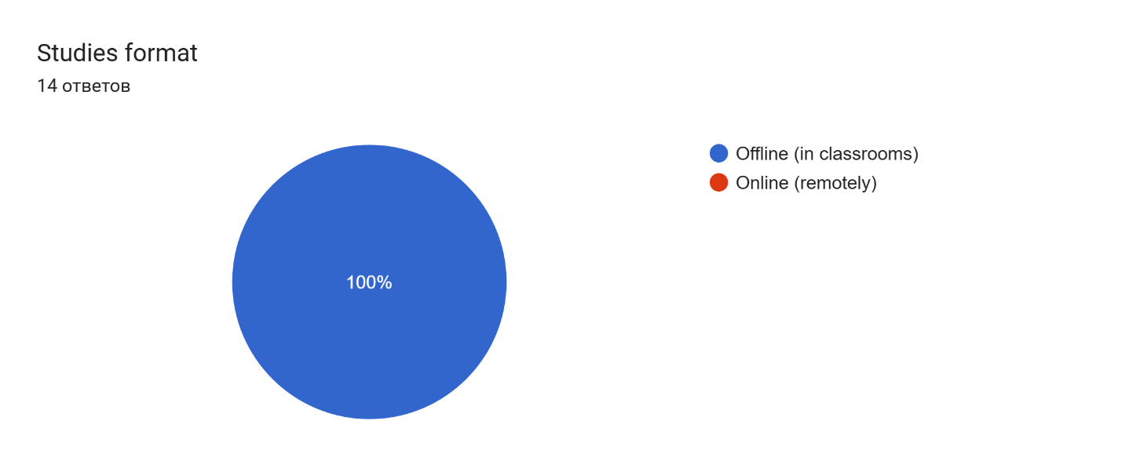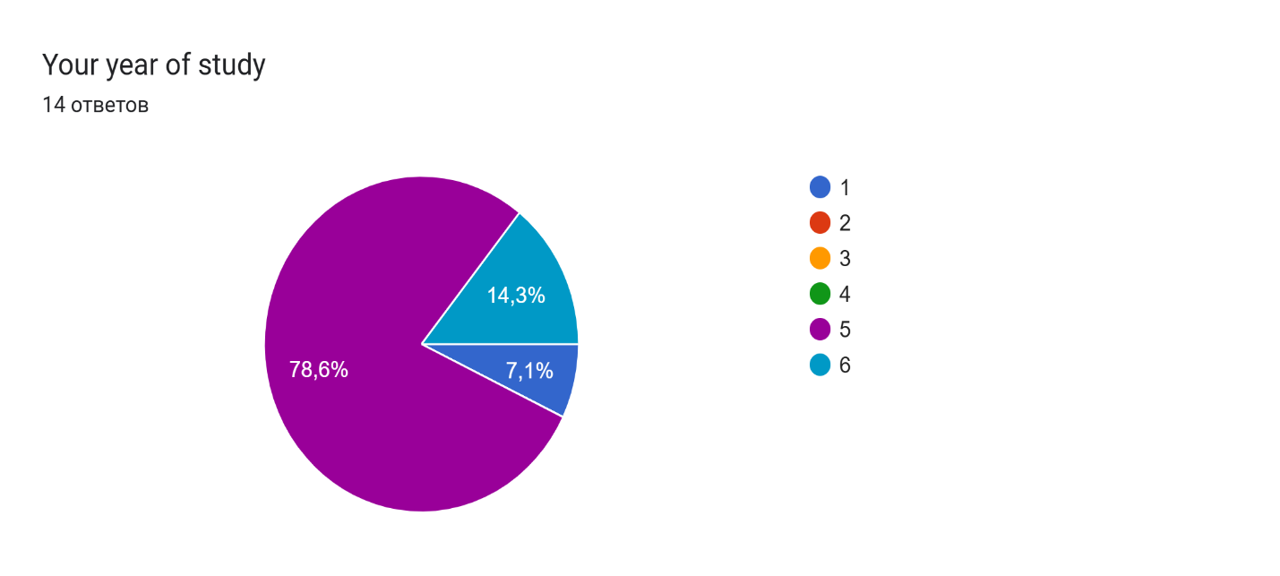

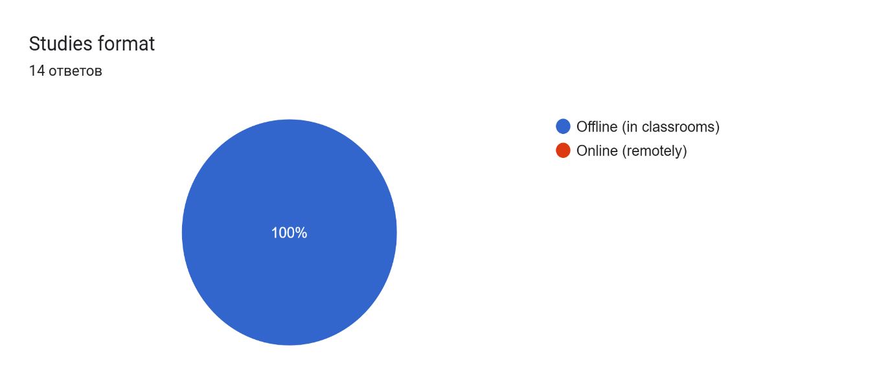

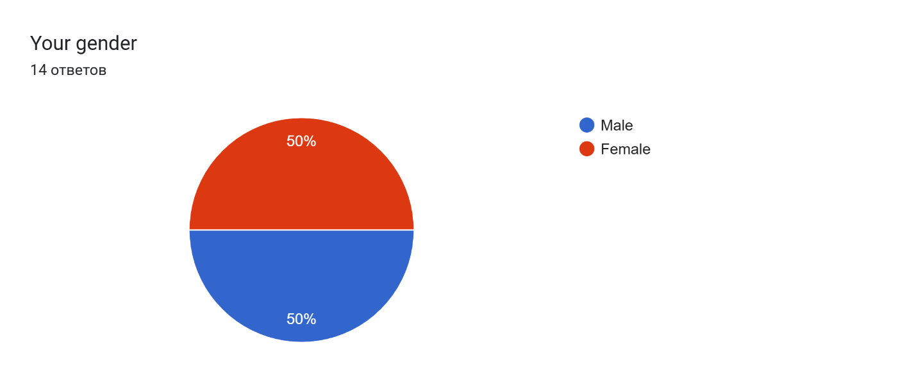

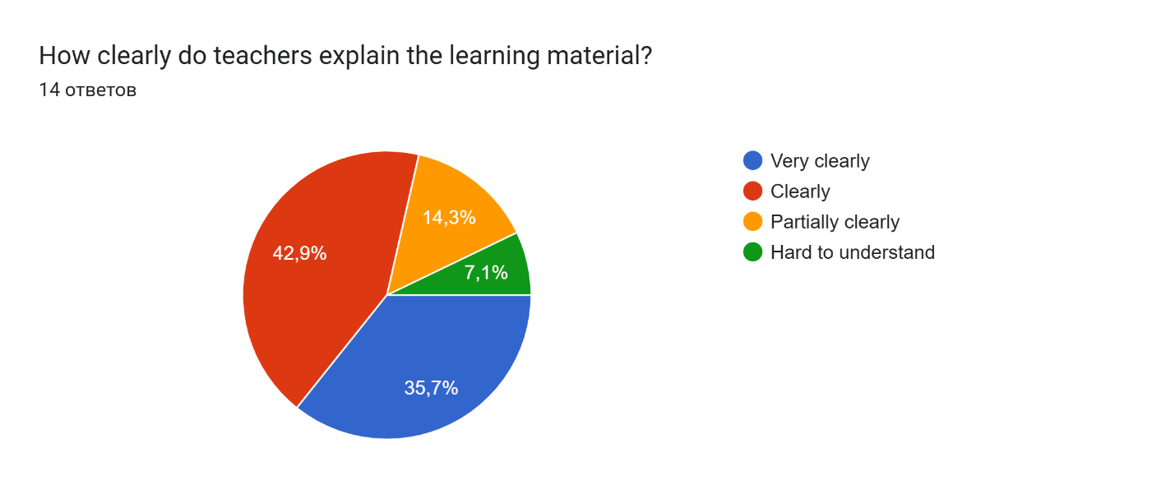

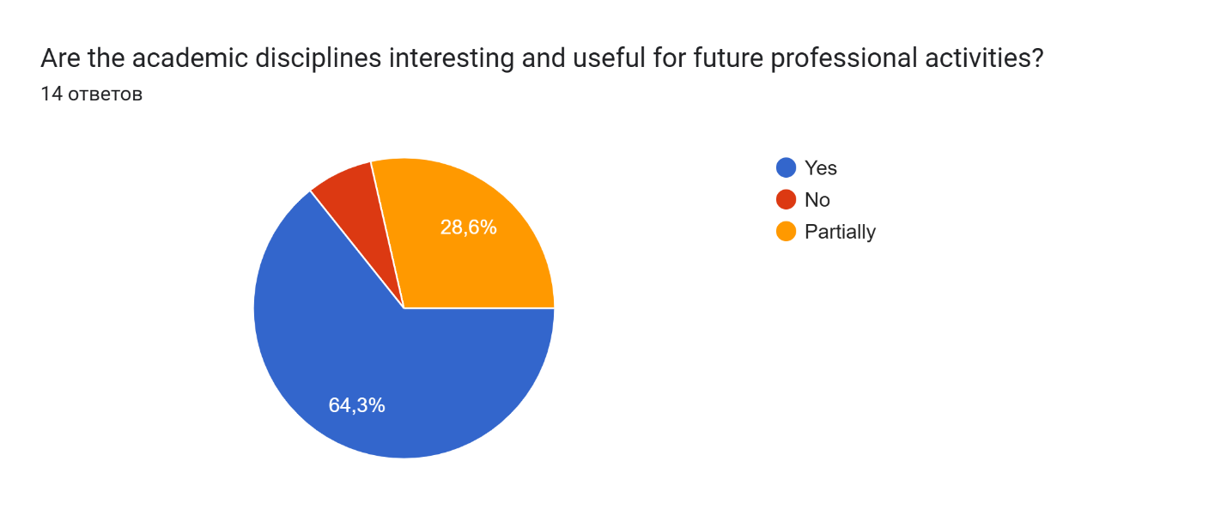

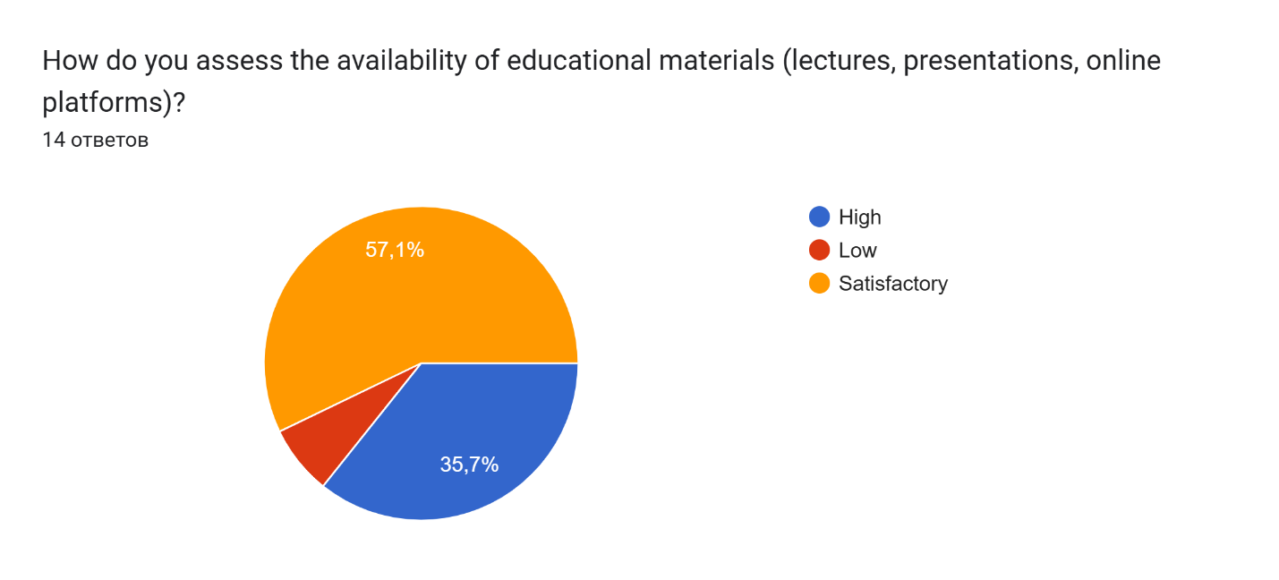

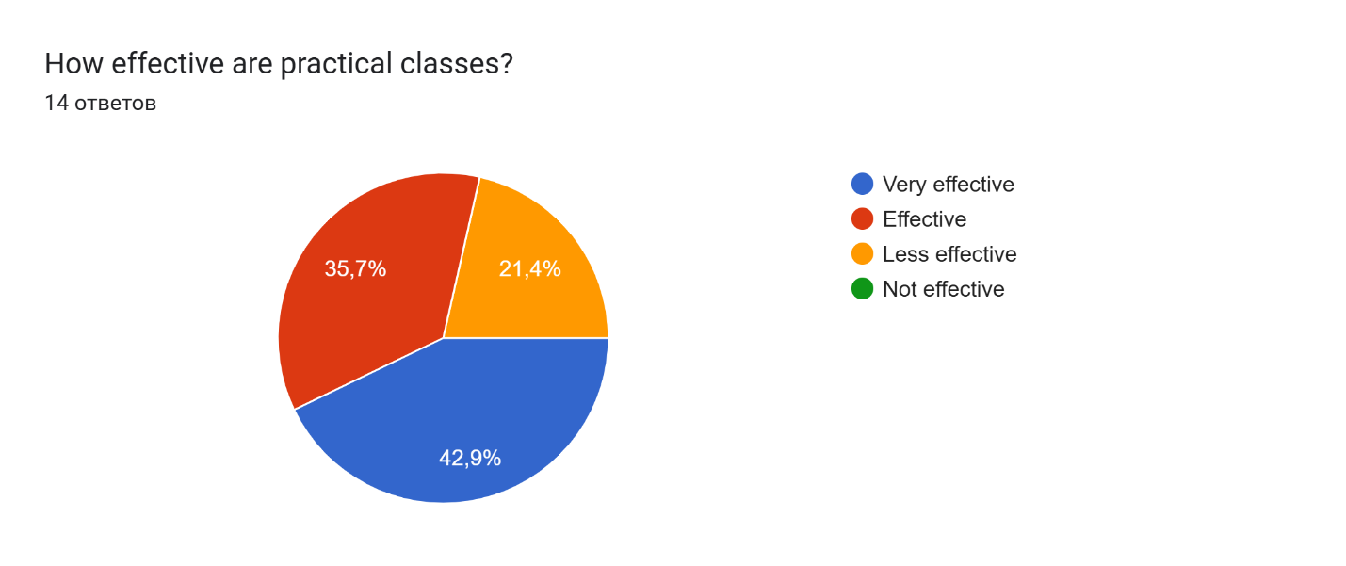

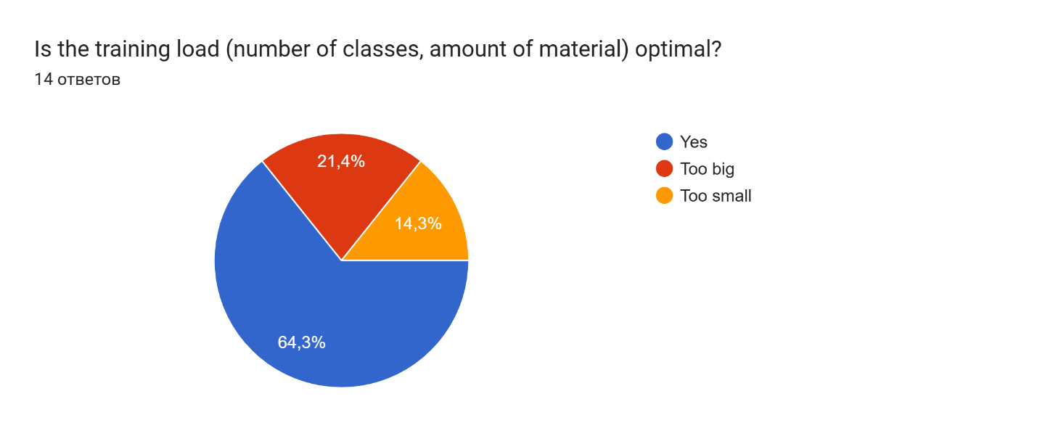

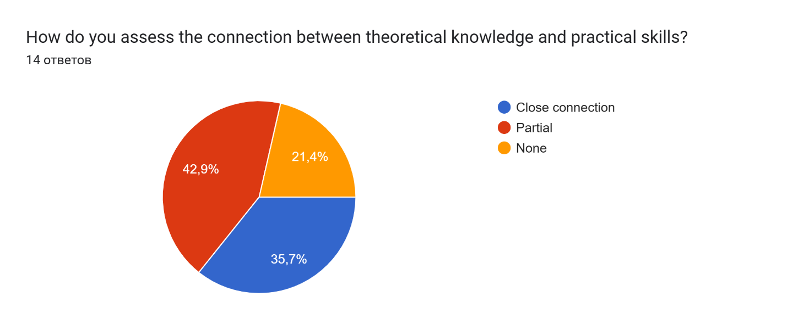

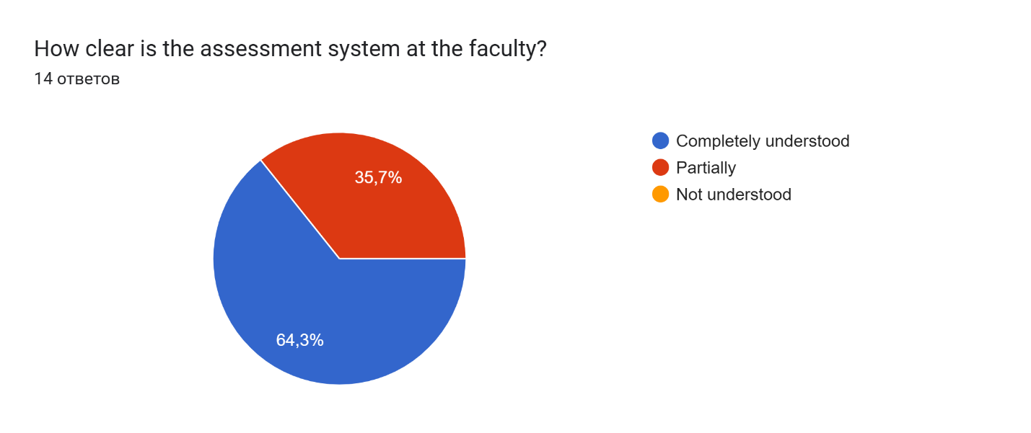

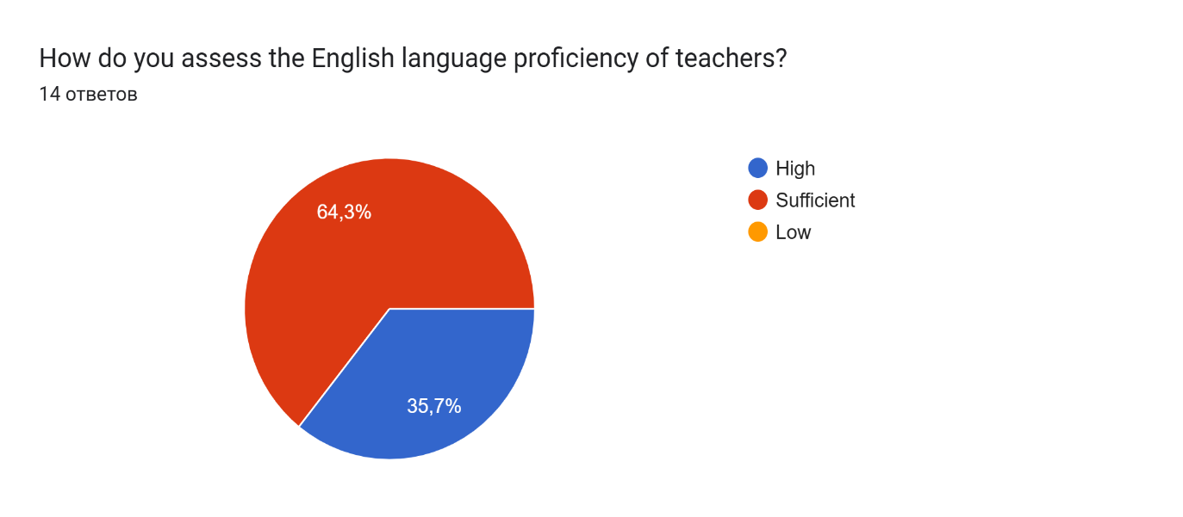

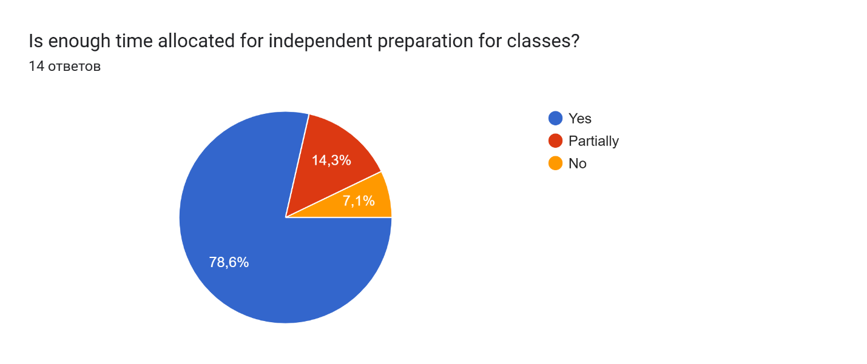

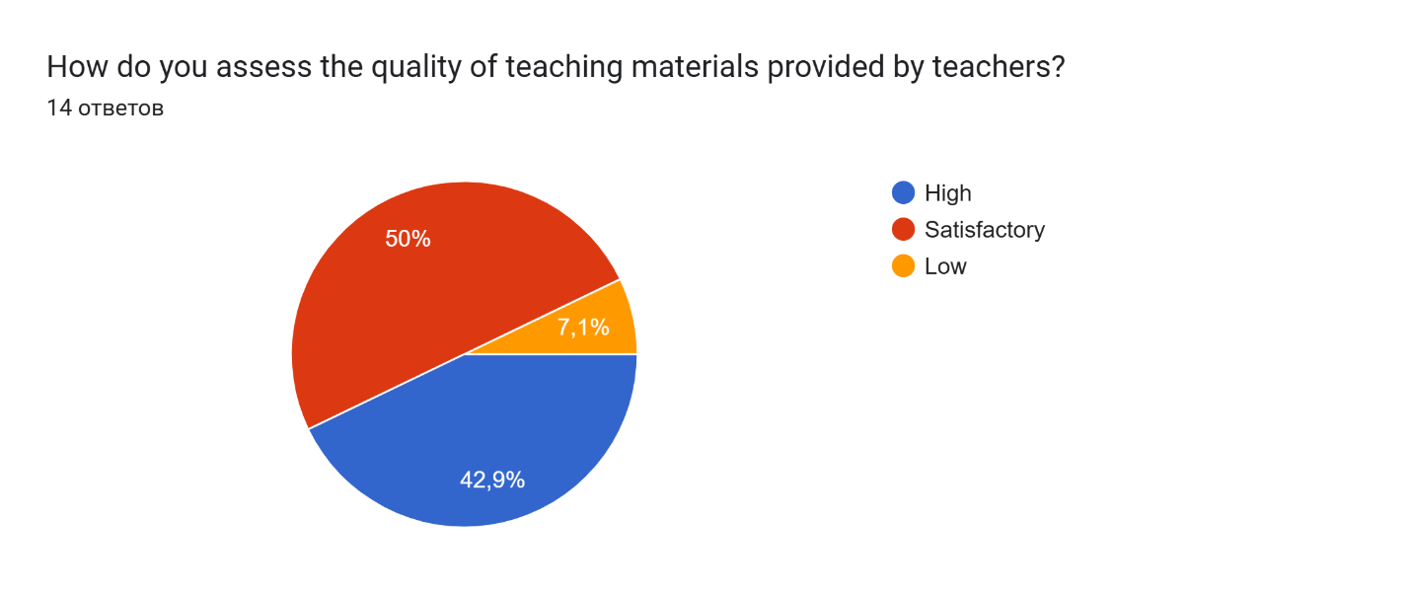

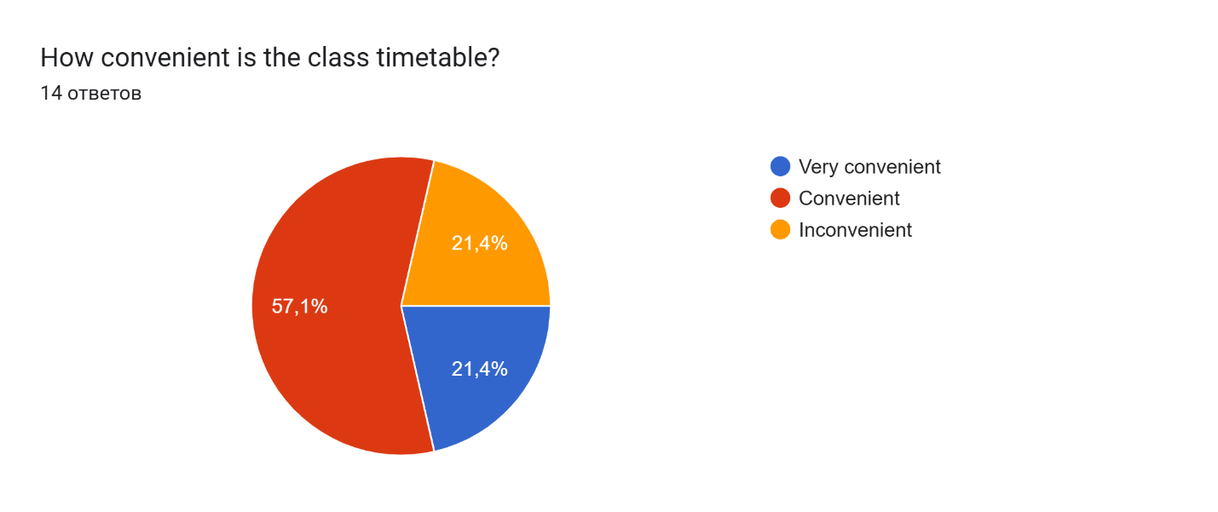

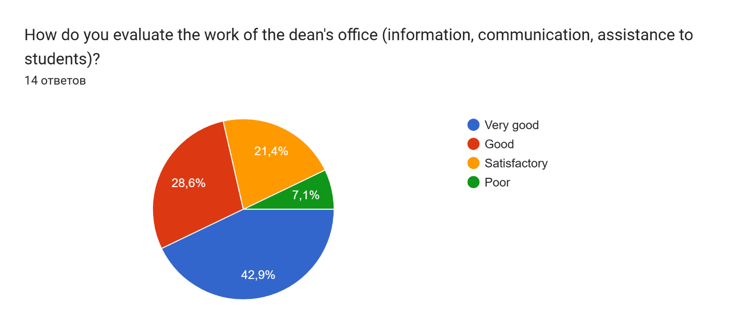

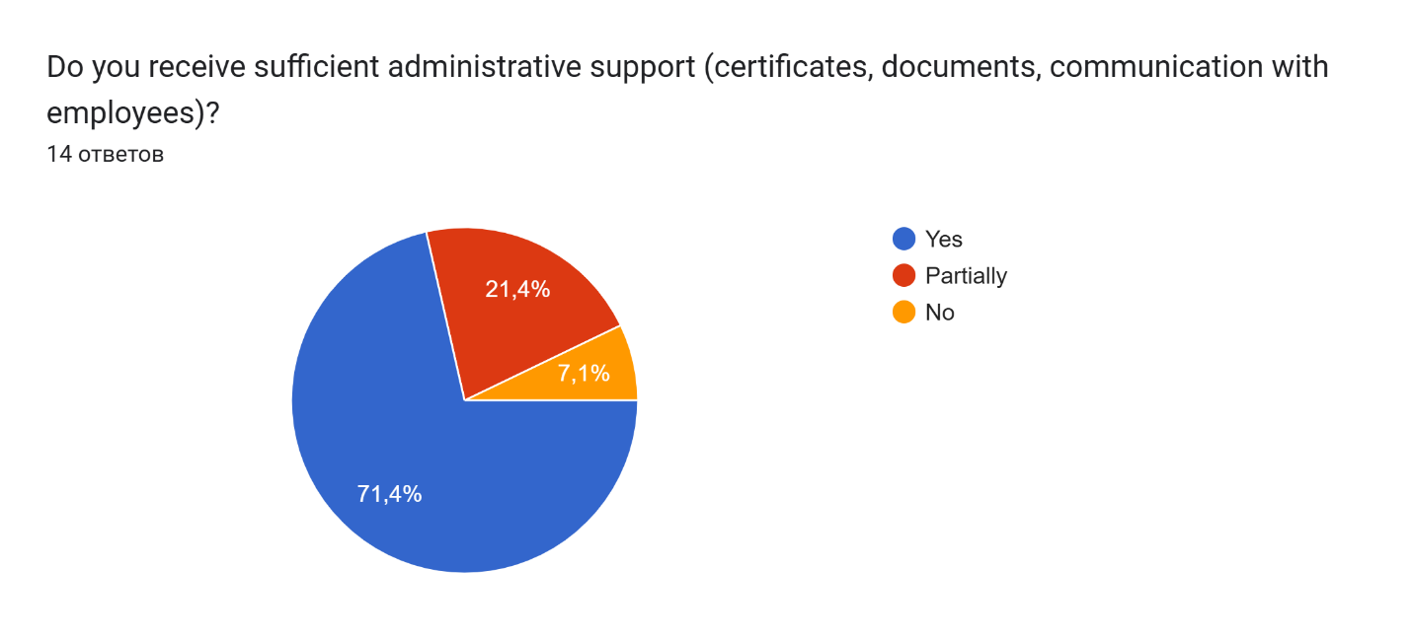

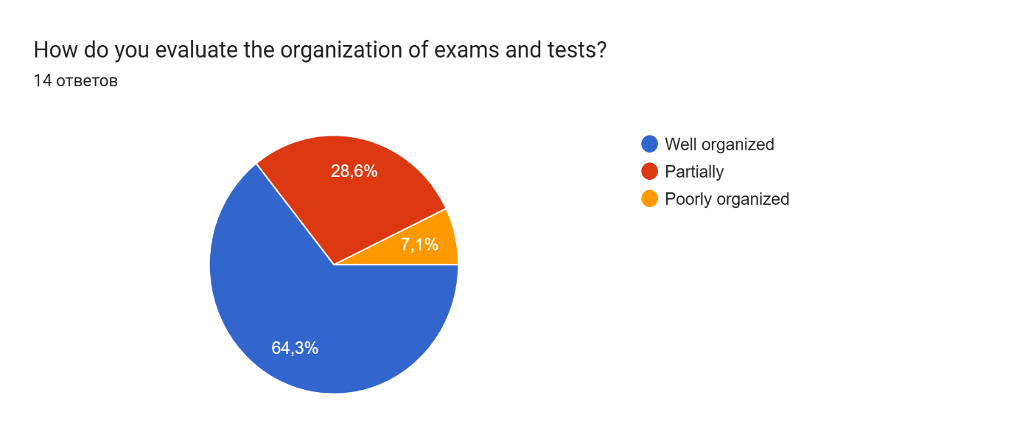

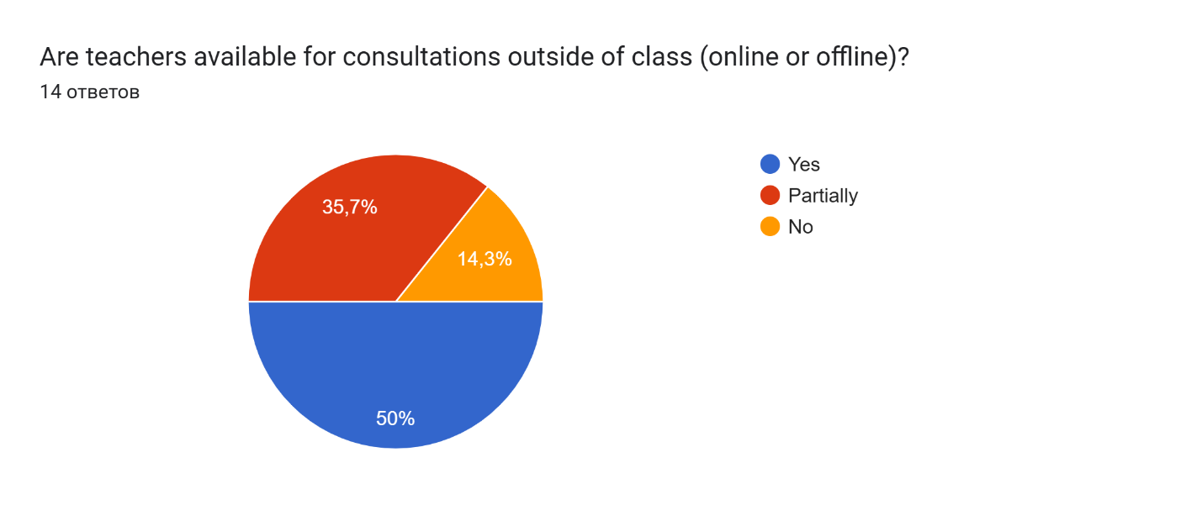

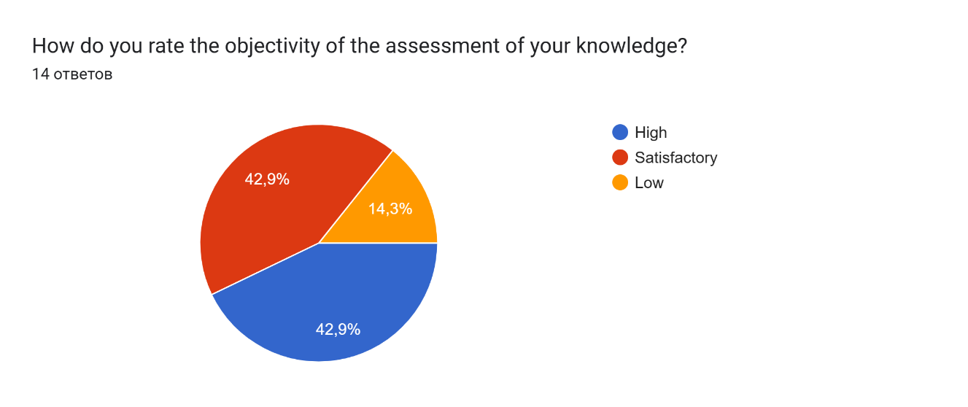

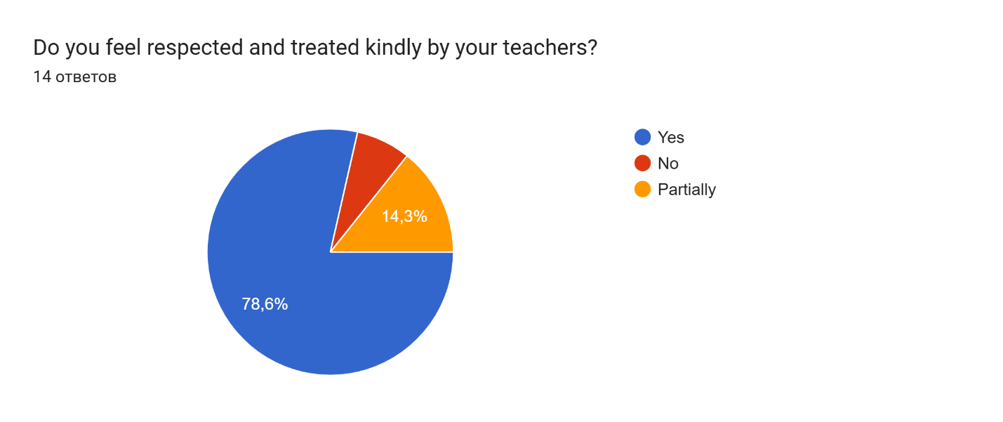

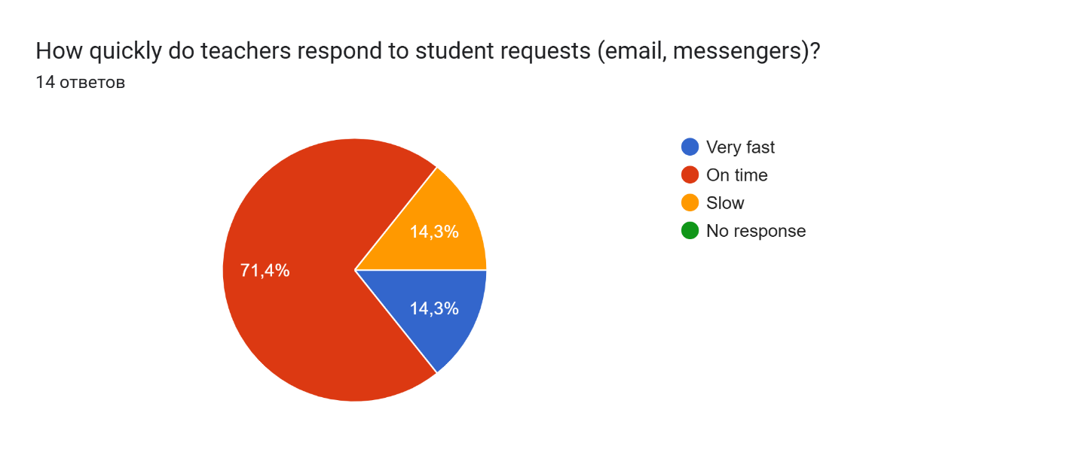

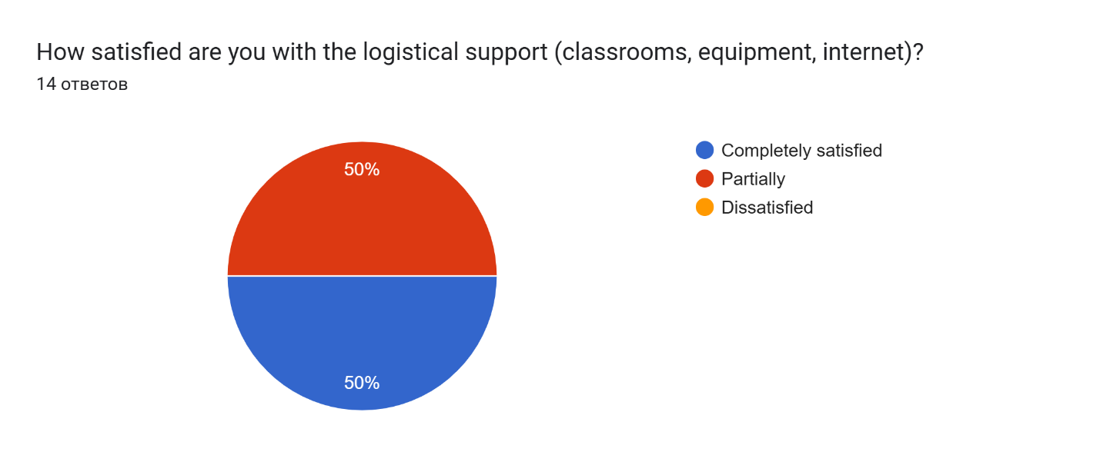
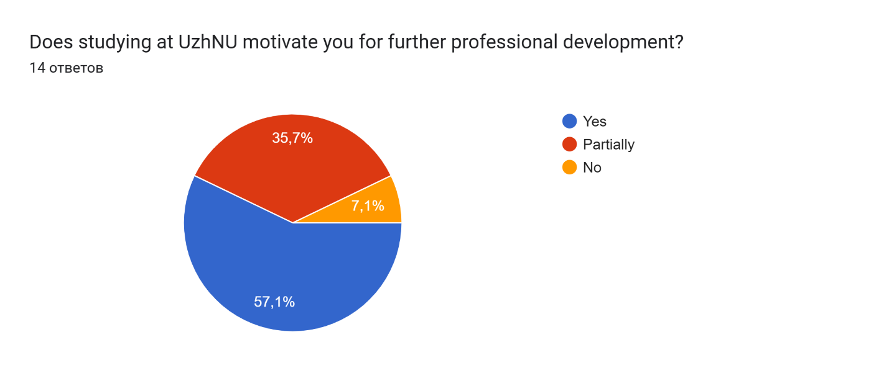

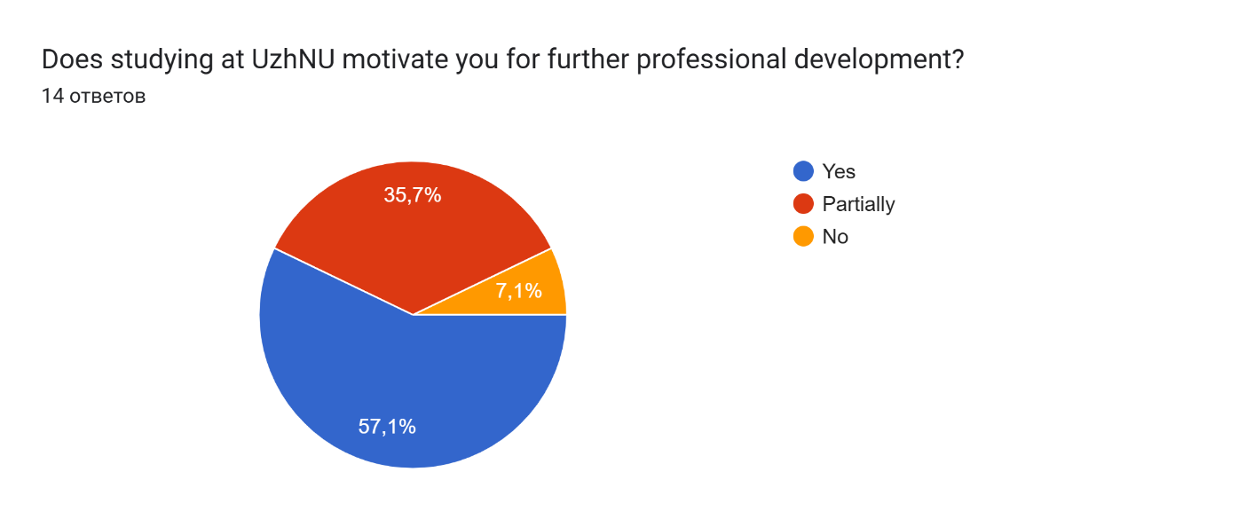

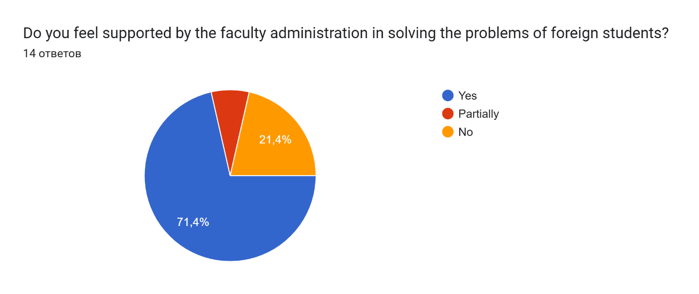

VI. Suggestions
What aspects of teaching do you think need improvement?
9 ответов
I think more practical knowledge and skills.
Everything is good
More patients exposure or practical skills… what happens is some groups get to do everything but some other group dont get to
More access to clinical practice
Most of the teachers just expect us to read on our own and they ask without teaching anything. I think it’s better they teach and then ask after. Some of our classes don’t even hold at all and we are just asked to do MCQS on Moodle.
Some areas that could be improved include adding more practical exposure and demonstrations along with the theoretical explanations. Interaction with patients during classes or clinical postings would make understanding much better.
Practical classes
The teachers should more focus on practical approach , show us patients for clinical exposure and more knowledge.
The interaction between the administration and the students (especially foreigners)
What do you like most about studying at the faculty?
8 ответов
I like mostly everything here.
Comunication between teacher and student and practical classes
The academic program
Nothing. To be honest, it has made me lose all my motivation for becoming a doctor.
I really appreciate that the teachers explain the topics very clearly and make sure students understand the concepts. They are supportive and approachable, which makes the learning environment comfortable and motivating.
Mostly practical knowledge is given together with theoretical
Very good discipline.
The times that we do get practical skills taught
Your suggestions or wishes for improving the educational process:
9 ответов
1) more practical skills 2) more interactive 3) classes should be at one or two location only, because if we have 4 classes a day than we have to go 4 different locations and it is very hectic for us. 4)students should be informed about the researches so that nobody cant miss it. I mean there should be information about the researches or about the teachers who will helps the students about researches so that we can start to do our research earlier.
Everything thing is good
Regular practical skills
More Time for clinical practice
More practical than theoretical skills. We are here to learn how to be good doctors.
It would be very helpful if more practical sessions, demonstrations, and patient interactions were included regularly. Also, for foreign medical students, assigning duties during emergencies under the supervision of a responsible person would greatly improve clinical understanding and confidence.
Better schedule and more clinical practice
Conduct more clinical exposure and clinical practice for gaining more knowledge.
More practical classes, more support for foreign students

