HEPATOLOGY
Approach to the patient
History
Except for patients who are extremely ill, the taking of a thorough and careful medical history should precede examination and treatment. An accurate history will often suggest the correct diagnosis and determine what investigations are necessary. It is important to remember that the individual consulting a doctor may be nervous and apprehensive, so it is essential they are put at ease by a friendly greeting and made to feel the centre of the interviewer’ s interest.
Begin the interview by introducing yourself, giving your name and position and asking consent to take a history. Ask open questions and allow patients adequate opportunity to answer in their own words as this is more likely to direct you to the patient ’ s underlying concerns rather than what you perceive their problem to be.
Once you have allowed the patient to give their own account of their problems it may be necessary to ask a series of direct questions to clarify the patient ’ s account and to extract further information regarding their previous health, family history and social matters.

Presenting complaint
The history begins with asking about the patient’s main complaint. Begin with an open question such as ‘What is the main problem with your health?’ or ‘When were you last completely well?’ Patients may have more than one presenting complaint. Record each presenting symptom in their own words rather than using medical interpretations of what was said. It is important to be sure you
know what the patient means since their interpretation of medical terms may be different to yours. For instance, a patient reporting a stomach ache may not be referring to a problem in the upper gastrointestinal tract and could be describing a sensation anywhere in the abdomen from the suprapubic region to epigastrium.
Common hepatology presentations are given below.

History of presenting symptom
After eliciting a patient ’ s presenting complaint or complaints you should take a careful history of each one, establishing:
• The mode and time of onset.
• Progression of the symptom.
• Associated symptoms.
• The effect the symptom has on the patient ’ s life.
In order to obtain this information it is necessary to combine a series of open and directed questions. Success in achieving this requires a lot of practice that can only be obtained by spending time talking to patients.
Jaundice
Jaundice refers to the yellow discolouration of the sclera or skin. It is caused by the presence of excess bilirubin in the blood, which is deposited in tissues of the body, particularly those that contain elastin. It is usually seen first in the sclerae, which are rich in elastic fibres, and in patients with dark skin this may be the only site that it can be recognised. Often the relatives or a doctor notices jaundice before the patient does. Jaundice can be classified into prehepatic, hepatic and posthepatic causes:
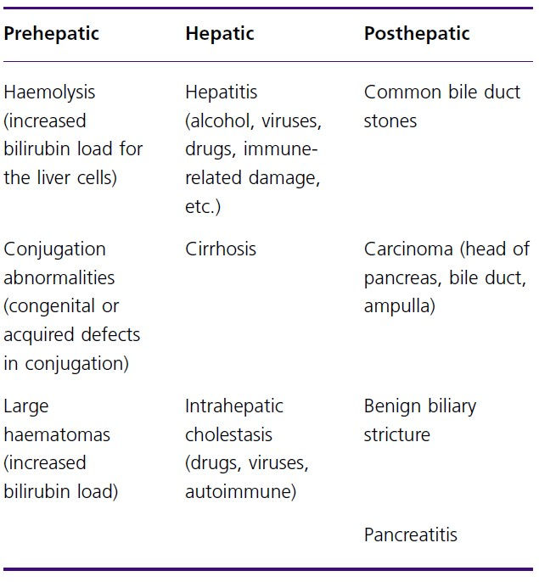

If a patient presents with jaundice the following questions should be asked:
• What is the colour of the urine and stools? (Pale stools and dark urine occur with intra - or extrahepatic biliary obstruction.)
• Is there a history of abdominal pain? (Gallstones, for example, can cause right upper quadrant pain and jaundice.)
• Is there a history of fever, sweats or rigors? (Suggests that the infection is either in the liver or biliary tree.)
• Does the patient itch? (Suggests obstruction to the bile flow.)

Common presentations in hepatology
• Jaundice
• Abdominal pain
• Abdominal swelling
• Gastrointestinal bleeding
• Encephalopathy
• Pruritus (itch)
• Asymptomatic but referred due to the incidental finding of abnormal blood tests or imaging or picked up via screening for a relevant risk factor
• Was there a prodromal illness? (May suggest viral hepatitis.)
• Is there a history of weight loss? (In an older patient this may suggest malignancy.)
• Has there been a recent outbreak? (Suggests viral hepatitis, e.g. infection with hepatitis A virus.)
• Is there a risk factor for viral hepatitis? For example, recent travel to an endemic country (e.g. in Africa or Asia), sexual exposure, recreational drug use or receipt of blood products.
• Has the patient taken any drugs?
• What is their alcohol consumption?
• Is there a family history of jaundice?

Abdominal pain
Abdominal pain is a common presentation with many causes. Careful history taking will steer investigation to the appropriate organ system and will often lead to the correct diagnosis. The following questions should be considered:
• Site and radiation: Ask the patient to point to the area affected by the pain and enquire about radiation of the pain.
Liver and biliary pain usually affects the epigastrium and right upper quadrant of the abdomen.
Hepatobiliary pain may radiate to the right shoulder tip due to diaphragmatic irritation. Sometimes the pain is only felt in the shoulder tip which can lead to difficulties in diagnosis as patients may be thought to have chest or
rheumatological causes for the pain.
Pancreatic pain is felt in the epigastrium and often radiates to the back.
• Frequency and duration: It is important to determine whether the pain is acute or chronic, when it began, how long it lasts and how often it occurs.
• Character and pattern: Pain that comes and goes in waves is related to peristaltic movements and is known as colic. It typically suggests pain related to the bowel and ureters.
Whilst biliary pain is frequently called ‘ biliary colic ’ this is often a misnomer as biliary pain is in fact rarely colicky.
Cystic duct obstruction tends to cause a severe pain in the epigastric region that is constant and can last for several hours.
If cholecystitis develops, the inflammation causes the pain to shift to the right upper quadrant and to become more severe.
• Exacerbating and relieving factors:
Biliary pain may be precipitated by consumption of fatty meals since the presence of fat in the gastrointestinal tract stimulates gallbladder contraction via production of the hormone cholecystokinin.
Patients with pancreatic pain may obtain some relief by sitting up and leaning forward.
• Associated symptoms:
Nausea and vomiting are common associated symptoms of biliary and pancreatic pain.
Itch suggests obstruction to biliary flow which may reflect an intrahepatic or extrahepatic process.
Abdominal swelling
Persistent swelling of the abdomen often suggests fluid accumulation within the peritoneal cavity (ascites). Other causes of abdominal swelling must be considered (for instance fat, pregnancy, flatus, faeces, organomegaly and an abdominal tumour), but these can usually be differentiated from ascites from the history and subsequent physical examination.
If a patient is thought to have ascites, questions should be asked to try to differentiate other processes from a hepatic cause. For example, a diagnosis of heart failure might be suggested by symptoms of breathlessness, chest pain or a past history of ischaemic or valvular heart disease. A history of renal disease could suggest nephrotic syndrome and gynaecological or gastrointestinal symptoms may point to a malignant cause.
Gastrointestinal bleeding
Patients with liver disease may develop portal hypertension, which can lead to the development of anastomoses between the portal and systemic venous systems and the development of tortuous veins called varices. Haemorrhage may occur from these vessels and can be torrential and life threatening.
Haematemesis (vomiting blood) indicates that the site of the bleeding is proximal to or at the duodenum. Whilst haematemesis in a patient with liver disease may be caused by bleeding from oesophago - gastric varices the other common causes of acute gastrointestinal bleeding should always be considered.
Causes of haematemesis and melaena:
Common causes:
• Peptic ulcer disease (duodenal ulcer, gastric ulcer, erosions)
• Inflammation (oesophagitis, gastritis, duodenitis)
• Oesophageal and/or gastric varices
• Mallory – Weiss tear
Less common causes:
• Dieulafoy lesion (ecstatic submucosal artery)
• Vascular abnormalities (angiodysplasia, arteriovenous malformations, gastric antral vascular ectasia)
• Aortoenteric fistula
• Gastric carcinoma or other neoplasm
• Bleeding diathesis
• Alternative origin, e.g. nasopharyngeal bleeding or haemoptysis
Melaena refers to the passage of black, tarry stools and usually results from bleeding from then upper digestive tract, although right - sided colonic or small bowel lesions can occasionally be responsible.
Haematochezia is the passage of bright red blood per rectum. It usually indicates a colonic cause such as diverticular disease, angiodysplasia or carcinoma.
Patients with liver disease may develop rectal bleeding secondary to rectal varices and rarely patients can present with haematochezia caused by massive haemorrhage from the upper gastrointestinal tract in the absence of haematemesis.

Encephalopathy
Patients with liver disease may develop portosystemic encephalopathy, a neuropsychiatric syndrome with disturbance of cognition and conscious level. This condition occurs in both cirrhosis and acute liver failure. Themechanism is not fully understood but impaired metabolic function of the liver in combination with blood bypassing the liver through portosystemic collaterals, allows ‘ toxic ’ metabolites direct access to the brain to produce the encephalopathy.
Patients will rarely recognize the presence of encephalopathy so friends and relatives should be interviewed and asked about alteration in personality, mood and concentration. An early symptom is reversal of the normal sleep pattern with daytime somnolence but an inability to sleep at night.

Pruritus
Patients with liver disease, particularly cholestasis, may describe intense itch which can be disabling. This is often worse in the peripheries and at night.

Past medical history
A thorough review of past medical and surgical history is a mandatory part of the history. Many medical and surgical conditions can predispose to liver and pancreatico - biliary disease.
Examples include:
• A history of inflammatory bowel disease (either ulcerative colitis or Crohn ’ s disease) could suggest a diagnosis of autoimmune hepatitis or primary sclerosing cholangitis.
• Surgical procedures could result in jaundice from the anaesthesia (e.g. halothane), from hypoxic damage to hepatocytes (secondary to hypotension) or from direct
damage to the bile duct during abdominal surgery.
• A history of autoimmune diseases such as thyroid disease, rheumatoid arthritis or coeliac disease could indicate autoimmune liver disease.
• A history of diabetes, hypercholesterolaemia or obesity might suggest non - alcoholic fatty liver disease.
• A current or previous history of gallstones could indicate that abdominal pain is caused by gallstone pancreatitis or cholecystitis, or that jaundice is caused by stone
migration into the common bile duct resulting in biliary obstruction.
• A history of diabetes, arthritis or cardiac dysrhythmia or cardiomyopathy could indicate haemochromatosis.

Medication history
A full enquiry into past and present medication is a mandatory part of any medical history. A large number of drugs can interfere with bilirubin metabolism or affect the liver directly, for example:
• Acute hepatitis can result from halothane, nonsteroidal antiinfammatory drugs or phenytoin.
• Cholestasis may occur from a sensitivity reaction to many antibiotics and antipsychotic medications.
• Overdose of paracetamol (acetaminophen) can lead to acute hepatocyte necrosis.
• Fatty liver can result from the use of tetracycline, steroids or sodium valproate.
As well as asking about prescription medications it is also important to specifically enquire about exposure to drugs obtained from other sources. Jaundice, hepatitis, cholestasis and even liver failure have been associated with the use of illicit drugs (e.g. ecstasy), over the counter agents, herbal remedies and substances obtained over the internet (e.g. anabolic steroids).

KEY POINT: non - prescription drugs are a frequent cause of liver disease or jaundice and should be specifically enquired about in anyone presenting with suspected liver pathology.

Family history
A number of liver - related conditions can have a familial predisposition:
• A family history of jaundice may suggest haemolysis or familial hyperbilirubinaemia.
• If family members are affected by anaemia or have undergone a splenectomy, jaundice could be caused by an inheritied haemolytic anaemia.
• A relative with hepatitis B infection should alert you to the possibility of the patient being a chronic carrier of that virus or a jaundiced patient having recently acquired that virus.
• A family member with a history of iron overload requiring venesection, diabetes, heart or joint disease should prompt consideration of a diagnosis of haemochromatosis.

Social history
The social history is particularly important when enquiring about potential liver disease since alcohol and viral hepatitis are common causes. A detailed alcohol history is mandatory and should ascertain the volume and type of alcohol a patient is drinking to try to calculate the amount of alcohol per week in units. Detailed enquiry is necessary since patients often try to conceal the actual amount from health care professionals. Furthermore, patients often genuinely underestimate their alcohol consumption as the percentage and volume of alcohol served has increased dramatically over the past two decades.
For example, 20 years ago a typical glass of wine was 125 ml of 8% alcohol and contained 1 unit. Today a glass is more likely to be 175 ml or even 250 ml of 13 – 15% alcohol. Similarly beer used to be served as 3% alcohol but today is more likely to be 5% or even 9%. This needs to be borne in mind when estimating alcohol usage in units.
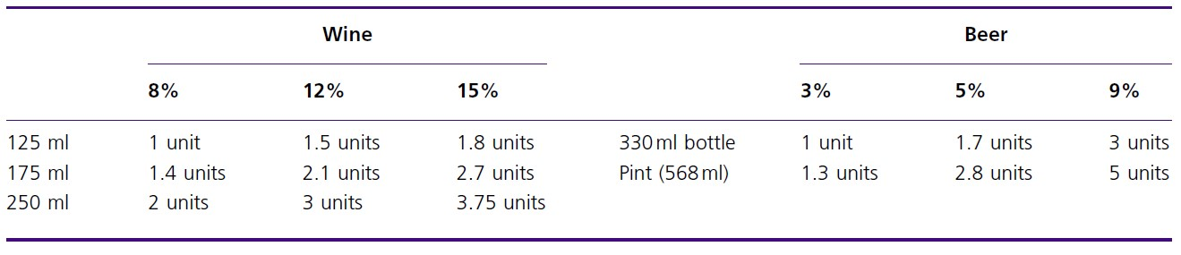
Safe recommendations for weekly alcohol intake are less than 14 units for women and less than 21 units for men.
A full sexual history should be obtained, asking specifically about unprotected sex. As hepatitis B has an incubation period of up to 6 months and can produce chronic disease over many years it is important to enquire about risk factors that may have occurred a long time ago. A
history of injections (e.g. intravenous drug use or tattooing) is important as hepatitis B and C can be transmitted in this way. It is not just sharing needles
that can put people at risk of acquiring blood – borne viruses; sharing equipment used to prepare the drugs as well as using the intranasal route of drug administration are recognised risk factors for virus transmission. A travel history is important in accessing possible exposure to viruses as hepatitis viruses are endemic in some areas of the world.

Examination
Preparation
You should begin by obtaining informed consent for the examination from the patient. The patient should be comfortable and positioned lying flat with their head resting on a single pillow to relax the abdominal muscles and facilitate abdominal palpation. Position a blanket to maintain patient dignity but remember that a full examination of the abdomen will include examination of the groins and genitalia in order not to miss important signs that can indicate life - threatening disease.
Routine
When examining the abdomen it is important to remember that there are a number of organ systems contained within it. The account below mainly outlines a schema to focus on disorders of the hepatobiliary system but the possibility of pathology in other systems (e.g. renal or gastrointestinal) must always be considered.
The examination follows the standard routine of inspection, palpation, percussion and auscultation. In patients with liver disease a lot of information can be gained from examining the limbs, face and chest and these areas must not be forgotten in the eagerness to examine the abdomen. Patients should be examined methodically and at the end of the examination the findings should be presented in the same order:
• General inspection from the end of the bed.
• Hands and arms.
• Face.
• Neck and chest.
• Abdomen.
• Groins, perineum and legs.

General inspection
After introducing yourself and positioning the patient, take a few steps back and look carefully at the patient and around the bed. If available you should look at:
• Medication.
• Dietary restriction, e.g. low salt, NBM (nil by mouth).
• Other equipment (IV cannula, urinary catheter, nasogastric tube).
• Temperature chart.
Next look at the patient but continue to resist the temptation to begin physical examination as much useful information can be obtained from careful observation.
Note the general appearance of the patient:
• Are they resting comfortably or in obvious pain? Visceral pain, such as seen in cholecystitis, might result in a restless patient; peritoneal pain, such as that caused by a perforated viscus, usually produces a still patient but inspection of the face will usually suggest that they are in pain.
• Are there features of weight loss present? Look for folds of loose skin; observe whether clothes are too big. Chronic liver disease tends to result in muscle wasting
which is often obvious in the face and upper limbs.
• Is the patient alert and cooperative or are they drowsy or confused, which might suggest encephalopathy?
• Examine the colour of the patient ’ s skin. Is there jaundice (yellow discolouration of the skin and sclera) or pigmentation (haemochromatosis may produce a ‘ bronze ’ pigmentation due to haemosiderin stimulating melanocytes to produce melanin)?
Hands and nails
Next take the patients hands and examine them carefully. Time spent examining the hands is well spent as there are many signs there that give clues to the presence of chronic liver disease. None of these signs are specifi c for liver
disease, however, but the presence of one or more of them are suggestive.
Finger clubbing
Clubbing is swelling of the soft tissue of the end of the fingers or toes. Inspection from the side reveals a loss of the angle between the nail bed and the finger and palpation may reveal an increased sponginess of the nail bed. Eventually the distal phalanx becomes enlarged due to the soft tissue swelling. The mechanism of clubbing is uncertain but it may result from arteriovenous shunting
in the lungs producing arterial desaturation that results in dilatation of the vessels of the fi ngertips or toes.
Causes of clubbing
• Abdominal: cirrhosis, inflammatory bowel disease, coeliac disease, gastrointestinal lymphoma;
• Cardiac: congenital cyanotic heart disease, subacute bacterial endocarditis
• Respiratory: pulmonary fibrosis, chronic pulmonary infection (e.g. bronchiectasis, abscess, empyema), cancer
• Other: thyrotoxicosis, familial, idiopathic
Leuconychia
Leuconychia is the term given to the white discolouration of the nails seen when they opacify. There is often a rim of pink nail bed at the top of the nail. Leuconychia occurs in hypoalbuminaemia, which may be secondary tomchronic liver disease, but is also seen in nephrotic syndrome and protein - losing enteropathies. The mechanism is uncertain but may reflect compression of capillary flow by extracellular fluid accumulation.
Dupuytren ’ s c ontracture
Dupuytren ’ s contracture is a thickening of the palmar fascia that causes permanent flexion of the fingers, most often the ring finger. In the early phases it may not be visible but can be felt as a thick ridge by the examiner ’ s thumb palpating across the patient ’ s palm. It is often bilateral and occasionally affects the soles of the feet. If it is found in a patient with liver disease it strongly suggests
alcoholism. It can also be seen in manual workers and may be idiopathic.
Palmar erythema
This is a reddening of the palms of the hands which is especially prominent over the thenar and hypothenar eminences. It is seen in chronic liver disease but also in pregnancy, thyrotoxicosis, rheumatoid arthritis andmpolycythaemia. The aetiology is uncertain but it may reflect raised oestrogen levels that occur due to impaired hepatic metabolism of sex hormones.
Hepatic flap
Before leaving the hands examine for the presence of a hepatic flap or asterixis. Ask the patient to stretch out their arms in front of them, extend the wrists and spread their fingers apart. Irregular jerky movements at the wrists and fingers indicate the asterixis of hepatic encephalopathy. You should examine the patient in this position for 20 – 30 seconds to exclude confidentally a flap.
Asterixis is usually present bilaterally but the movements are not synchronous on each side. The mechanism is thought to reflect metabolic interference with the flow of joint position sense information to the brainstem. The flap is characteristic of liver failure (acute or chronic) but can also be seen in cardiac, respiratory and renal failure.
Arms
Examination of the patient with suspected liver disease requires a thorough inspection of the arms as many clues to the presence of liver disease may be found there. Again, these are not specific but their presence can be a strong indicator of liver pathology.
Spider naevi
Spider naevi are abnormal vessels usually found on the skin in the area drained by the superior vena cava (i.e. the arms, head and neck, and upper chest wall), the reason for this distribution is not known. They consist of a central arteriole with small vessels radiating out from it resembling spiders ’ legs. Pressure applied at the central arteriole causes the entire lesion to blanch. They are usually a few millimetres in size but occasionally can be up to a centimetre. One or two may be seen in healthy individuals but the presence of more than two is abnormal. They are sometimes seen in the latter stages of pregnancy or in women on the contraceptive pill raising the suggestion that they are caused by oestrogen – mediated dilatation on arterioles. They occasionally bleed but the main concern they cause the patient is usually cosmetic.
Bruising
Examination of the arms of a patient with liver disease frequently reveals bruising (ecchymoses) reflecting the clotting abnormalities seen in liver disease. These may be spontaneous or occur at the site of previous venipuncture or intravenous cannulation.
Petechiae
Pin - sized bruises may also be present and usually suggest thrombocytopenia. This may be caused by platelet sequestration and destruction in an enlarged spleen in portal hypertension or bone marrow depression, which is often a feature of chronic alcohol consumption.
Scratch marks
Patients with obstructive jaundice or cholestasis may be troubled by severe itch (pruritus). This sensation is often so intense that patients cannot resist the urge to itch and can frequently scratch until they bleed leaving grazes and marks on their skin.
Muscle wasting
Before leaving the upper limbs carefully inspect them for evidence of loss of muscle bulk, which is often seen in severe chronic liver disease or in a patient with underlying malignancy.
Face
Jaundice
Examine the sclera carefully for jaundice as this is often the only site that it can be detected clinically. Jaundice is the only condition to cause yellow sclera, so if the skin is yellow but not the sclerae then a diagnosis other than jaundice should be sought (e.g. carotenaemia).
Kayser– Fleischer rings
These are brownish green rings at the periphery of the cornea, tending to affect the upper pole more than the lower. They are due to deposits of excess copper in Descemet ’ s membrane of the cornea. They are difficult to see, especially in dark eyed individuals, and a slit – lamp examination is often necessary to demonstrate them.
They are most commonly associated with Wilson ’ s disease, a copper storage disease that causes cirrhosis and neurological symptoms, but can also be seen in patients with other cholestatic liver diseases. They are much loved in picture books and exams but very rarely seen in clinical practice.
Xanthelasma
These yellowish plaques in the subcutaneous tissues in the periorbital region are due to deposits of lipids. They may indicate chronic hypercholesterolaemia. They can be seen in patients with cholestasis and are particularly common in patients with primary biliary cirrhosis.
Parotid enlargement
Palpate the cheeks to examine for enlargement of the parotid glands. This can be seen in alcoholism, which causes fatty infiltration of the gland.
Hepatic fetor
Examine the mouth closely and note the presence of fetor hepaticus, a rather sweet smell of the breath which is present with severe hepatocellular dysfunction. It is important to familiarise yourself with this smell since detection of its presence in a patient with a coma of otherwise unknown cause can be a very helpful clue to
the diagnosis of hepatic encephalopathy.
Neck and chest
Palpate the cervical lymph nodes, which can be involved in advanced intra - abdominal malignancy. Examine the chest wall for spider naevi and for the presence of gynaecomastia in males. Enlargement of the breast tissue may occur in cirrhosis, particularly alcoholic cirrhosis, and is thought to reflect alteration in the oestrogen : testosterone ratio. Spironolactone, used to treat ascites in cirrhosis and other conditions, is another cause of gynaecomastia, as are digoxin and cimetidine.
Abdomen
Now attention can be turned to the abdomen itself.
Inspection
Look for abdominal scars that may indicate previous surgery or trauma. Note the presence of generalized abdominal distension that could reflect ascites but will
need to be differentiated from fat, flatus, faeces, organomegaly and tumours. Localised swellings may indicate a tumour mass, enlargement of one of the abdominal or pelvic organs or a hernia.
In a patient with liver disease and portal hypertension, prominent veins may be obvious on the abdominal wall. Blood flows through portosystemic anastomoses into the umbilical veins, which become engorged and distended. The direction of flow is away from the umbilicus. This sign is called a caput Medusae (head of Medusa), likening the appearance to the mythical Medusa ’ s hair after it had been turned into snakes. This needs to be differentiated from venous engorgement secondary to inferior vena cava obstruction when the direction of flow in the engorged veins is upward towards the heart.
Palpation
This part of the examination often reveals the most information but in order to achieve this it is vital that the patient is comfortable and the abdominal muscles are relaxed. Ask the patient if any area is painful before you start and examine this area last. Encourage the patient to breathe gently throughout the examination and to inform you if there is any tenderness.
The abdomen is divided into nine regions and each area should be palpated with the palmar surface of the fingers:
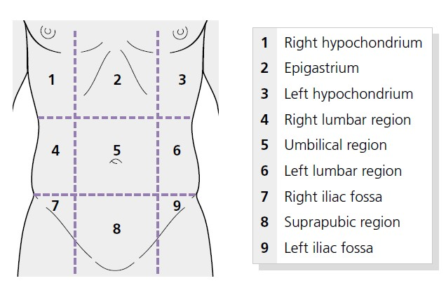

Begin with light pressure in each region, noting the presence of any tenderness or lumps in each region. Next perform firmer palpation to detect deeper
masses, taking care to avoid the tender areas until the end of the examination. Note the presence of guarding, resistance to palpation that occurs due to contraction of the abdominal muscles. This may be voluntary due to anxiety or tenderness; involuntary guarding suggests peritonitis. After superficial and deep palpation, the presence of organomegaly should be specifically sought.
Hepatomegaly
An enlarged liver can often be palpated in the abdomen below the right costal margin. The examining hand should be held parallel to the costal margin with the lateral margin of the forefinger towards the lowest rib. Ask the patient to breathe in and out slowly and keeping your hand still feel for the liver edge as it descends in inspiration.
It is important to begin examining in the right iliac fossa so as not to miss the edge of a massively enlarged liver. With each expiration, advance the hand 1
or 2 cm closer to the right costal margin. This examination should continue into the epigastrium as it is not uncommon for the left lobe of the liver to be palpable to
the left of the midline in cirrhosis. If the liver edge is felt examine its surface for tenderness and to determine whether the liver is hard or soft, regular or irregular, and whether it is pulsatile.
There are many causes of an enlarged liver:
Causes of hepatomegaly
Common causes
• Alcohol - related liver disease with fatty infiltration
• Right heart failure
• Metastases
• Hepatitis
• Fatty liver disease (e.g. secondary to diabetes and the metabolic syndrome)
Other causes
• Malignancy (hepatocellular carcinoma, myeloproliferative disorders, lymphoproliferative disorders)
• Infections (infectious mononucleosis, malaria, HIV, hepatic abscesses, hydatid disease)
• Haemochromatosis
• Infiltration (e.g. amyloid)
• Biliary obstruction
Tender liver
• Hepatitis
• Rapid enlargement (right heart failure, Budd – Chiari syndrome)
• Hepatic abscesses
Pulsatile liver
• Tricuspid regurgitation
• Vascular abnormalities
• Hepatocellular carcinoma
Firm, irregular liver
• Cirrhosis
• Metastatic disease
It is important to remember that liver disease can also result in a small liver that may not be palpable. For example, in cirrhosis the fibrous scarring usually results in a small shrunken liver, and in acute liver necrosis the liver shrinks rapidly due to hepatocyte death.

The gallbladder
The gallbladder lies below the right costal margin where this crosses the lateral border of the rectus muscles. It is not usually palpable in health but if it is enlarged may be felt as a focal rounded mass that moves down on inspiration.
In cholecystitis, palpation at the costal margin causes severe pain when the inflamed gallbladder presses on the examiner ’ s hand (Murphy ’ s sign).
The causes of an enlarged gallbladder are listed below.
Causes of gallbladder enlargement:
With jaundice:
• Carcinoma of the head of the pancreas
• Carcinoma of the ampulla of Vater
• Gallstone formed in the common bile duct in the absence of gallbladder stones
Without jaundice:
• Empyema or mucocoele of the gallbladder
• Carcinoma of the gallbladder
• Acute cholecystitis
It is important to remember Courvoisier ’ s law, which states that an enlarged gallbladder in a patient with jaundice is unlikely to be due to gallstones as this situation usually results in a chronically inflamed and fibrotic gallbladder incapable of enlargement. In a jaundiced patient, a palpable gallbladder is more likely to be caused by carcinoma of the head of the pancreas or lower biliary tree, resulting in biliary obstruction:
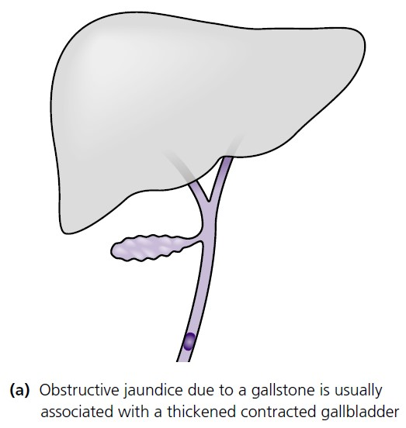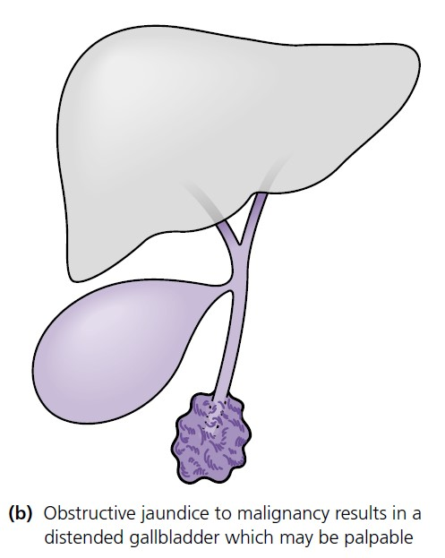
The reverse is not necessarily true however, an impalpable bladder in a jaundiced patient may be due to gallstones but other causes are also possible since it is common for a gallbladder to be dilated but impalpable.
Splenomegaly
An enlarged spleen cannot usually be detected clinically until it is about twice its normal size. In the early stages of enlargement, the spleen can be felt just below the left costal margin towards its lateral margin. Further enlargement causes it to project inferiorly and medially.
Examination for an enlarged spleen should therefore begin in the right iliac fossa so as not to miss a massively enlarged spleen. Begin with the hand flat on the abdomen with the index finger parallel to the left costal margin.
Keeping the hand still ask the patient to breathe in and feel for the spleen tip descending in inspiration. In expiration advance the examining hand towards the left costal margin. Palpation of a slightly enlarged spleen can be helped by using a two - handed approach. As the right hand approaches the costal margin use the left hand to compress firmly posterolaterally over the lower rib cage so as to remove the tension in the abdominal wall. If the spleen is not palpable, the patient should be rolled onto their right side towards the examiner and palpation using the two - handed technique repeated. The causes of hepatosplenomegaly and splenomegaly are given below.
Causes of splenomegaly
Massive splenomegaly
• Haematological (myelofibrosis, chronic myeloid leukaemia, primary lymphoma of the spleen)
• Portal hypertension
• Infection (malaria, Kala azar)
Moderate splenomegaly
• The above causes
• Haematological malignancy (e.g. lymphoma, leukaemia)
• Thalassaemia
• Storage disorders (e.g. Gaucher ’ s disease)
Small splenomegaly
• The above causes
• Other myeloproliferative disorders (essential thrombocytosis, polycythaemia rubra vera)
• Haemolytic anaemia
• Connective tissue disorders (e.g. rheumatoid arthritis, systemic lupus erythematosus, polyarteritis nodosa)
• Infection: bacterial (e.g. infective endocarditis, tuberculosis); viral (e.g. Epstein – Barr virus, viral hepatitis); protozoa (e.g. malaria)
• Infiltration (e.g. amyloid, sarcoid)
Causes of hepatosplenomegaly
• Chronic liver disease with portal hypertension
• Infection (e.g. acute viral hepatitis)
• Haematological disease (e.g. myeloproliferative disease, lymphoma, leukaemia, pernicious anaemia, sickle cell anaemia)
• Connective tissue disorder (e.g. systemic lupus erythematosus)
• Infiltration (e.g. amyloid, sarcoid)
• Thyrotoxicosis
• Acromegaly

Other organs
If you are asked to examine the abdomen then an attempt to palpate the kidneys must be made. Even if hepatobiliary disease is suspected it is necessary to consider a renal mass in the differential diagnosis of a right or left subcostal mass.
Kidneys are best felt by bimanual palpation with the patient lying flat on his or her back. For the right kidney place the left hand underneath the patient ’ s back
with the palm in the right loin and the flexing fingers in the renal angle. Press this hand forward whilst the right hand presses down on the anterior abdomen above it.
With this technique, called balloting, the kidney may be felt between the two hands. The opposite hands are used for the left kidney. The features that differentiate a kidney from a spleen are given below. Other masses may be palpable on abdominal examination.
Differences between a spleen and kidney on clinical examination
• The upper border of the spleen cannot be palpated as it lies above the costal margin. The upper border of the kidney can be palpated
• The spleen has a notch which can be palpated. The kidney does not have a notch
• The kidney is ballottable between the two examining hands because of its retroperitoneal location. The spleen is not usually ballottable
• The spleen moves inferomedially towards the right iliac fossa on inspiration whereas the left kidney moves inferiorally towards the left iliac fossa
• Percussion over the spleen is usually dull but percussion over the kidney is resonant as it lies underneath gas - filled bowel
If a mass is found then it should be fully characterized asking the following questions:
• What is the site of the mass? State the region of the abdomen involved.
• Is it possible to palpate above it?
• What is its size and shape?
• Is the surface smooth or irregular?
• Is the edge regular or irregular?
• What is the consistency (e.g. hard or soft)?
• Is the mass mobile? Does it move on inspiration?
• Is it pulsatile?
• Is there any tenderness?

Percussion
Abdominal percussion is performed to define the size and nature of organs and masses, to find out whether distension is due to gas, free fluid (ascites), encased fluid (e.g. a cyst) or a solid mass and to elicit tenderness in a patient with peritonitis.
Liver
The liver borders should be percussed to determine the total liver span. Percuss down the chest along the midclavicular line noting where the percussion note changes from resonant to dull, normally level with the sixth rib. The measurement from this point to the palpable liver edge gives the liver span, usually less than 12 cm in health. If the liver edge is palpable, assessing the liver span is important to determine whether the liver is enlarged or merely displaced downwards, for example by overinflated emphysematous lungs. With experience it is also possible to define a small, shrunken cirrhotic liver by percussion.
Spleen
Percussion is not a particularly helpful method of detecting an enlarged spleen but can sometimes be helpful if it is doubtful whether the tip can be felt.
Ascites
Accumulation of fluid within the peritoneum may be suspected by inspection and palpation but must be confirmed by percussion. Percussion over the abdomen
normally produces a resonant note due to air within the gastrointestinal tract. If peritoneal fluid (ascites) is present the percussion note becomes dull. The liquid
gravitates to the dependent part of the abdomen, thus in the supine patient there is dullness in the flanks and this dullness shifts when the patient is rotated onto their side.
This phenomenon is referred to as shifting dullness. When examining for ascites place the left hand on the abdomen over the midline with the fingers of the left hand pointing to the feet. Strike the middle phalanyx of the left middle finger with the tip of the right middle finger. Percuss from the resonant centre of the abdomen into the left flank until the percussion note becomes dull.
Keep the left hand in place and ask the patient to roll onto their right side. Pause for a few seconds to allow the fluid to move then repeat percussion. If the percussion note has become resonant and percussion back towards the umbilicus re - establishes a dull note, ascites is suggested.
Occasionally a large ovarian cyst or fluid within dilated bowel in small intestinal obstruction can cause confusion.
In massive ascites, a fluid thrill may be detectable although this is not examined for routinely. Ask an assistant to place a hand firmly on the centre of the abdomen.
Flick the side of the abdominal wall and feel for a pulsation (thrill) with the other hand placed on the other side of the abdomen. An additional useful technique when there is significant ascites is dipping over the upper abdomen to determine if the liver or spleen is enlarged.
Place the hand flat on the abdomen and flex the fingers at the metacarpophalangeal joints rapidly to displace underlying fluid. The rapid displacement of fluid allows the fingers to reach an organ or mass covered in ascites.
Causes of ascites are given below.
Causes of ascites:
• Cirrhosis
• Congestive cardiac failure
• Intra - abdominal malignancy (e.g. gastrointestinal,
gynaecological)
• Pancreatitis
• Infection (e.g. pyogenic, tuberculosis)
• Budd – Chiari syndrome
• Meig ’ s syndrome *
• Nephrotic syndrome
• Protein - losing enteropathy
• Hypothyroidism

Auscultation
Many abdominal sounds have been described in patients with liver disease but in general it is rare for auscultation to be very contributory to the examination of the hepatobiliary system. It must be performed as part of the complete abdominal examination, however, and is essential so as not to miss vital signs that can suggest bowel obstruction or perforation.
Using the diaphragm of the stethoscope, listen over the abdomen for the presence and character of bowel sounds, friction rubs, arterial bruits and venous hums. If the liver is enlarged it is important to listen over its surface. A friction rub is a grating sound heard when the patient breathes; it is produced by inflammation in the liver capsule (e.g. by a liver tumour, a hepatic infarct, a recent liver biopsy or the very rare Fitz - Hugh – Curtis syndrome when a perihepatitis complicates pelvic inflammatory disease). Arterial systolic bruits are occasionally heard over the liver in hepatocellular carcinoma, acute alcoholic hepatitis or with an arteriovenous malformation. More commonly, arterial bruits are due to stenoses in the aorta, mesenteric or renal arteries. Rarely, a venous hum can be heard between the xiphisternum and umbilicus due to turbulence in the collateral circulation in portal hypertension.
Further examination
To complete the examination of the abdominal system it is essential to examine the hernia orifices, the external genitalia and perform a rectal examination.
Relevance of the rectal examination in liver disease
• Pale stools: obstructive jaundice/cholestasis
• Melaena: upper gastrointestinal bleeding (may identify the cause of encephalopathy in someone presenting in a coma)
• Constipation: may exacerbate encephalopathy
• Steatorrhoea: malabsorption which may be a feature of cholestasis

Examine the legs for pitting oedema. On finishing your examination thank the patient, help them back into their clothing and ensure that they are left in a comfortable position. A summary of the clinical examination of a patient with suspected liver disease is given below in the OSCE checklist.

Putting it all together
Once the history and examination findings have been recorded the information needs to be analysed in order to:
• Consider the differential diagnosis.
• Create a problem list. In some complicated cases it may be necessary to create a problem list considering new complaints, co - morbidities and social circumstances.
• Create a strategy for investigation.
• Develop a treatment plan.
• Arrange follow - up.
OSCE checklist for abdominal examination focusing on chronic liver disease 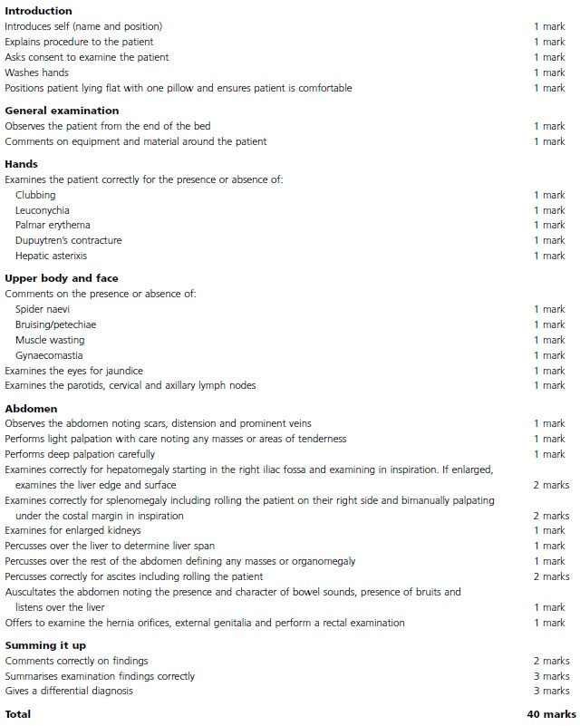
A plan for further review of the patient needs to be documented. If seen in the GP surgery or outpatient clinic this may be to be reviewed again when the results of investigations are available or to contact the patient to let them know the investigation results. A patient attending the emergency department may need to be admitted or discharged with investigations organized as an outpatient.
A plan for further review of the patient needs to be documented. If seen in the GP surgery or outpatient clinic this may be to be reviewed again when the results of investigations are available or to contact the patient to let them know the investigation results. A patient attending the emergency department may need to be admitted or discharged with investigations organised as an outpatient.

Investigations performed in hepatology
Blood tests
Blood investigations are an important aspect in managing patients with liver disease and are able to give insight into hepatic damage, hepatic function, aetiology of disease and prognosis.

Liver function tests
The term ‘ liver function tests ’ (LFTs) is a misnomer as these tests are not optimal measures of hepatic function (albumin and coagulation are more useful ‘ functional ’ tests). Nonetheless LFTS can alert clinicians to the possibility of underlying hepatic injury. Moreover, the pattern of abnormality in LFTS is often more helpful in clinical practice than individual test results.
The following are the most commonly used LFTs:
• Alanine aminotransferase (ALT): This is an enzyme that catalyses the conversion of alanine to pyruvate. It is present is high concentrations within hepatocytes so elevated levels suggest hepatocyte damage/necrosis.
• Aspartate aminotransferase (AST): AST is located in the mitochondrial membrane in hepatocytes but is also contained in erythrocytes, myocardium and skeletal muscle. In the context of liver disease it reflects hepatocellular necrosis. Generally, hepatitis results in a similar pattern of elevation in both AST and ALT. An elevated AST : ALT ratio, however, can indicate alcoholic liver disease or signify liver fibrosis in the context of non - alcoholic liver disease.
• Alkaline phosphatase (ALP): A number of isoenzymes of ALP exist including bone, intestine, placenta and liver. An elevation in the liver ALP isoform can be indicative of biliary disease or cholestasis (intrahepatic or
extrahepatic).
• Gamma glutamyl transferase ( γ- GT): This can be raised in a number of liver conditions including alcoholic liver disease, cholestasis and liver fi brosis. An elevated γ - GT can be helpful in the context of a raised ALP in suggesting a hepatic origin for the ALP.
• Bilirubin: This is elevated in haemolysis, cholestasis or impaired hepatic function. Distinguishing unconjugated (indirect) bilirubin from conjugated (direct) bilirubin can be useful in some cases.

Synthetic function
Prolongation of the prothombin time (PT) can imply significant liver disease as the liver is incapable of synthesizing normal coagulation factors. It can also occur in the presence of cholestasis or malnutrition due to interruption of gastrointestinal vitamin K absorption (a fat - soluble vitamin dependent on bile salts for absorption).
Administration of intravenous vitamin K will correct for any reduced absorption (due to biliary disease or malnutrition) but will not correct abnormalities related to hepatic synthesis.
Reduced serum albumin is a feature of chronic liver disease and a falling albumin has prognostic significance. It should be noted that any major insult causing a stress response (e.g. surgery, sepsis, injury, etc.) will lead to an
acute reduction in albumin production.

Renal function and electrolytes
Low urea and creatinine concentrations in liver disease reflect the reduced muscle mass that accompanies cirrhosis. Therefore absolute values of creatinine may falsely reassure and glomerular filtration rates or the relative change in creatinine may be a better indicator of renal function. It is particularly important to monitor renal function in decompensated cirrhosis as early diagnosis of renal dysfunction, with instigation of treatment, may reverse the condition.
In advanced cirrhosis, total body overload of salt and water occurs; body water retention exceeds sodium retention resulting in hyponatraemia. Secondary hyperaldosteronism is common in cirrhosis and results in hypokalaemia. Other electrolyte disturbances such as hypophosphataemia, hypomagnesaemia and reduced serum selenium are not uncommon in patients with advanced liver disease.
These may require correction by intravenous therapy to prevent refeeding syndrome when liver disease patients are hospitalised.

Full blood count
A pancytopenia (low white blood cell count, haemoglobin and platelet count) in cirrhosis occurs as a result of portal hypertension causing pooling of blood in the splanchnic circulation.
Certain aetiological agents (e.g. alcohol) can also cause bone marrow suppression.
The production of the hormone thrombopoietin, involved in the synthesis of platelets, is reduced in advanced liver disease and this will also contribute to the thrombocytopenia.
Haemolysis is associated with certain aetiologies of liver disease (e.g. autoimmune hepatitis, Zieve ’ s syndrome and Wilson ’ s disease).

Tests for the aetiology of liver disease
Liver disease is often asymptomatic and therefore blood tests are an important diagnostic tool in determining the aetiology of the disease. The chronic liver disease screen is a useful set of investigations in patients presenting with
chronically deranged liver function tests:
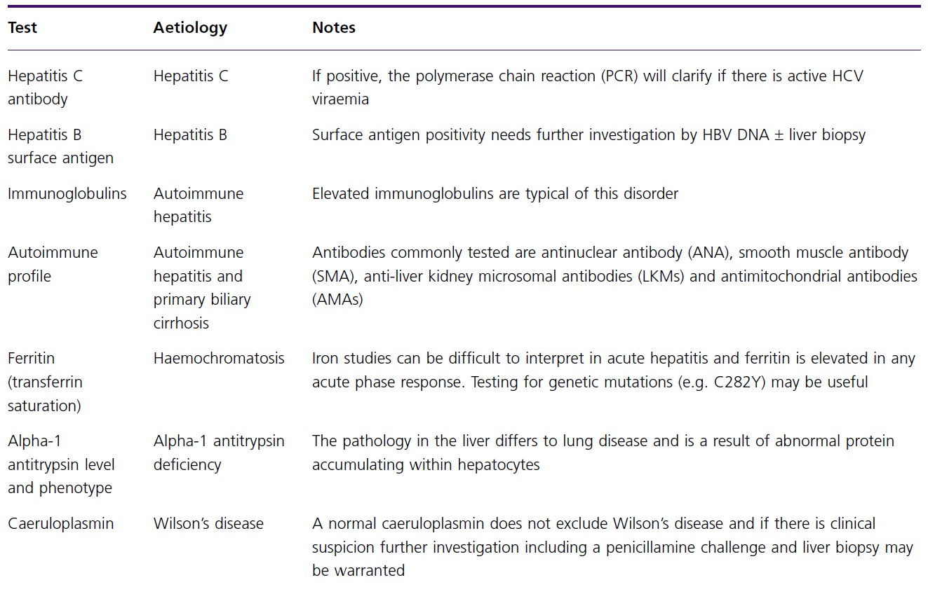

Tumour markers
The common tumour markers used in liver disease are α- fetoprotein (AFP) and CA 19- 9:
• A FP is produced by regenerating hepatocytes and therefore can be raised in chronic liver disease and cirrhosis per se . A single AFP reading has limitations but a persistently elevated AFP on follow - up is a strong indicator of hepatocellular carcinoma (HCC).
• CA 19- 9 is a commonly used tumour marker for cholangiocarcinoma. The sensitivity and specificity of the test is not optimal; for example, any cause of cholestasis or cholangitis may elevate the CA19 - 9. Therefore it can be rarely used to diagnose cholangiocarcinoma without support from radiological imaging or biopsy.
• CA 125 can be elevated in any cause of ascites; this needs to be considered in the context of investigating ovarian disease and coexisting liver disease.

Imaging
Hepatobiliary radiology is complex and close liaison with a hepatobiliary radiologist to decide on appropriate investigation and to aid interpretation in the correct clinical context is an important interface in clinical hepatology.

Ultrasound
Ultrasound (US) is a relatively inexpensive, non – invasive method of assessing the biliary system, the size and echotexture of the liver, vascular patency and in detecting space - occupying lesions within the live. It is a useful first - line imaging investigation for the jaundiced patient.
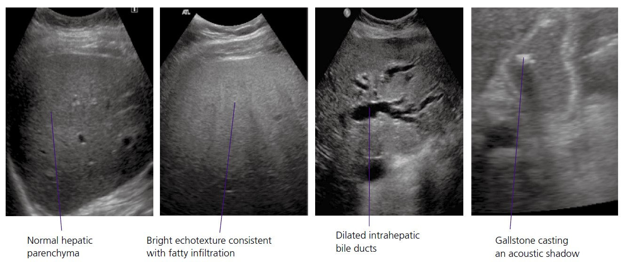
Liver ultrasound examination.

• Dilated intrahepatic bile ducts on US suggest an obstructive cause such as gallstones in the common bile duct, a pancreatic carcinoma or cholangiocarcinoma.
• Gallstones can easily be seen in the gallbladder using US. Stones in the common bile duct are more difficult to visualise by US and often require more specialist investigations such as magnetic resonance cholangiopancreatography (MRCP), computed tomography (CT) and endoscopic retrograde cholangiopancreatography
(ERCP).
• The cirrhotic liver may be enlarged (e.g. in non - alcoholic steatohepatitis), normal or reduced in size. The echopattern of the liver is frequently described as coarse (increased irregular echogenicity) in cirrhosis and the margin of the liver may be irregular.
• The presence of ascites and splenomegaly on US examination in patients with liver disease is strongly suggestive of cirrhosis (the main differential is portal vein
thrombosis).
• Doppler ultrasound provides a technique to measure blood flow in the portal vein, hepatic artery and hepatic veins. It measures the frequency differences between the
US signal emitted from the transducer and returned from the vessel; this generates direction and velocity of blood flow. The major vascular changes seen in cirrhosis reflect underlying portal hypertension. They include the reversal of portal vein blood from hepatopetal to hepatofugal, flattening of the Doppler waveform in hepatic veins, and enlargement of the portal vein to greater than 15 mm.
• Ultrasound is used as a screening tool to detect HCC on the background of cirrhosis. Isolated nodules, larger than 2 cm, are detected with a good sensitivity but a lower specificity. The performance of US in the presence of diffuse malignancy is poor. Confirmation of US findings of HCC are required by cross - sectional imaging (CT or magnetic resonance imaging (MRI)).

Computed tomography
• CT provides cross- sectional anatomy of the liver. With the advent of multislice CT scanning detailed information about space - occupying lesions can be gleaned with very short acquisition times.
• Helical CT can also utilise vascular anomalies of lesions by obtaining images in the arterial, portal venous phase and delayed phase (triple phase). For example HCC will typically have a brisk enhancement during the arterial phase but appears hypodense during the delayed phase (rapid washout).
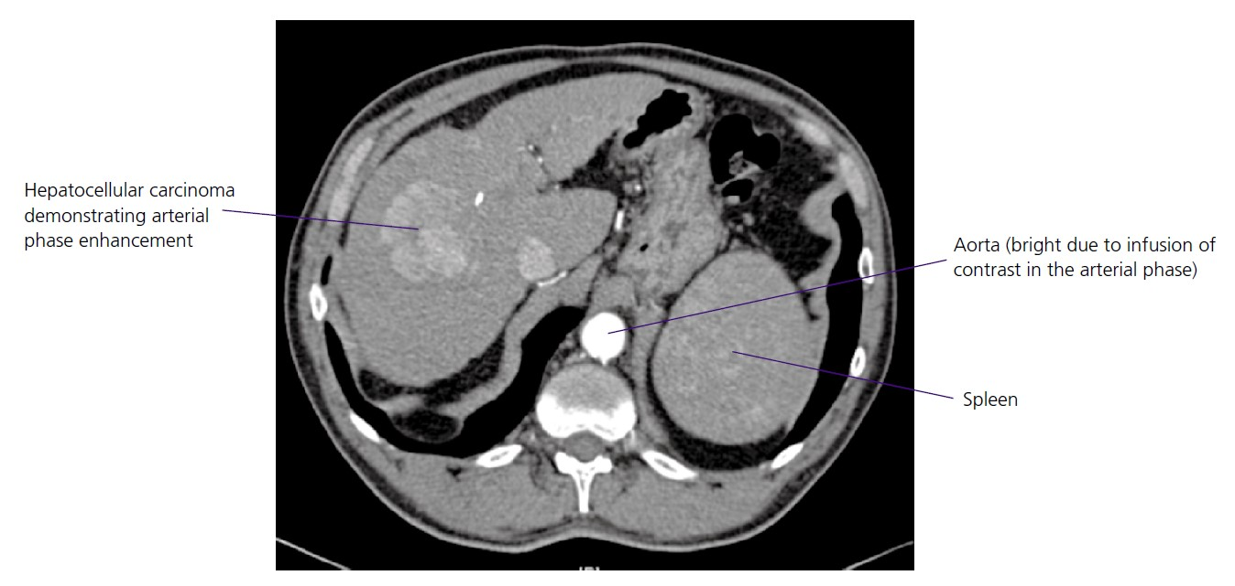
• Direct catheterisation of the superior mesenteric artery and hepatic artery can also be used in combination with CT to improve diagnostic accuracy. Therefore, CT in
isolation or combination with arteriography is able to provide a vascular ‘ road map ’ highlighting the blood supply of lesions or vascular anomalies.
• CT is not the ideal modality to assess liver parenchyma. However, in certain aetiologies changes in the density of liver parenchyma can be pronounced; e.g. increased density in haemochromatosis and decreased density in fatty infiltration.

Magnetic resonance imaging
More detailed images of liver parenchyma can be obtained by MRI compared to CT; furthermore patients are not subjected to ionising radiation. The major disadvantage is the availability of equipment and time required to acquire the images.
• MRI can be useful in diagnosing benign conditions such as haemangiomas, focal nodular hyperplasia and adenomas. The use of contrast agents such as lipiodol,
gadolinium and superparamagnetic contrast agents (e.g. resovist) are often utilised to separate benign lesionsn from HCC.
• MRI has been used to assess hepatic iron concentration.
• Magnetic resonance (MR) angiography (useful in assessing vasculature) and MR spectroscopy (with a role in assessing hepatic steatosis) are emerging areas of MRI.

MRCP and ERCP
• MRCP is a non - invasive method of assessing the pancreatic and biliary tree. With improving hardware and technical expertise it represents the preferred modality for the diagnosis of biliary gallstones in comparison to more invasive ERCP. In addition, it is useful in the diagnosis of conditions such as biliary strictures, primary sclerosing cholangitis, pancreatic divisum and cholangicarcinoma.
• ERCP is largely a therapeutic modality in modern – day practice. The specially designed endoscope has a side viewer allowing visualisation and cannulation of the
biliary and pancreatic tree. For gallstone disease, it allows the removal of gallstones and dissection of the ampulla of Vater (sphincterotomy). ERCP is also used to place stents across strictures of the pancreatic and biliary duct. The complications of ERCP include bleeding, pancreatitis and perforation of the bowel so considered thought should be given before undertaking the procedure.
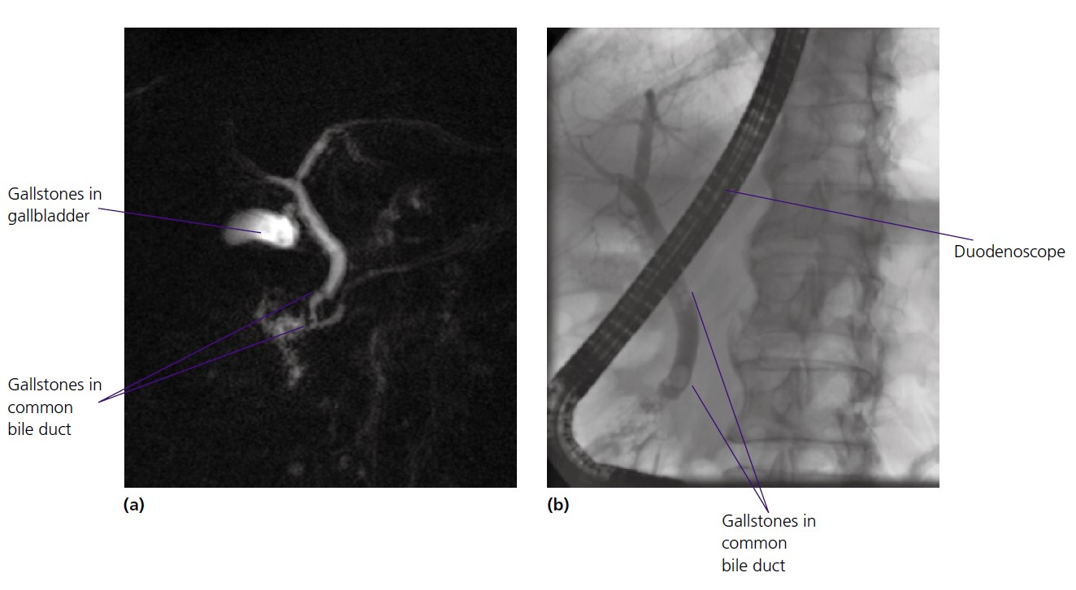
Common bile duct gallstones demonstrated by (a) MRCP and (b) ERCP.

Miscellaneous procedures
• Arteriography can be useful for detailed characterization of hepatic vasculature. In addition it may aid the diagnosis of HCC, find the source of haemorrhage within the liver and be part of therapy in HCC (transarterial chemoembolisation is when chemotherapy agents are delivered locally to the HCC and the feeding blood vessel to the tumour is simultaneously embolised).
• Percutaneous transhepatic cholangiography (PTC) is utilised by interventional radiologists to access the biliary tree.
It is often required in high strictures (e.g. hilar strictures) when access is not possible by ERCP.
• Endoscopic ultrasound (EUS) has become an important tool in hepatobiliary disease. In addition to staging disease (e.g. pancreatic carcinoma), it is used to obtain tissue for histological confi rmation. In the appropriate hands it is superior to MRCP for diagnosing cholelithiasis in the common bile duct and has an emerging role in the drainage of pancreatic pseudocysts, coeliac nerve plexus blocks in chronic pancreatitis and assessing submucosal gastric varices. 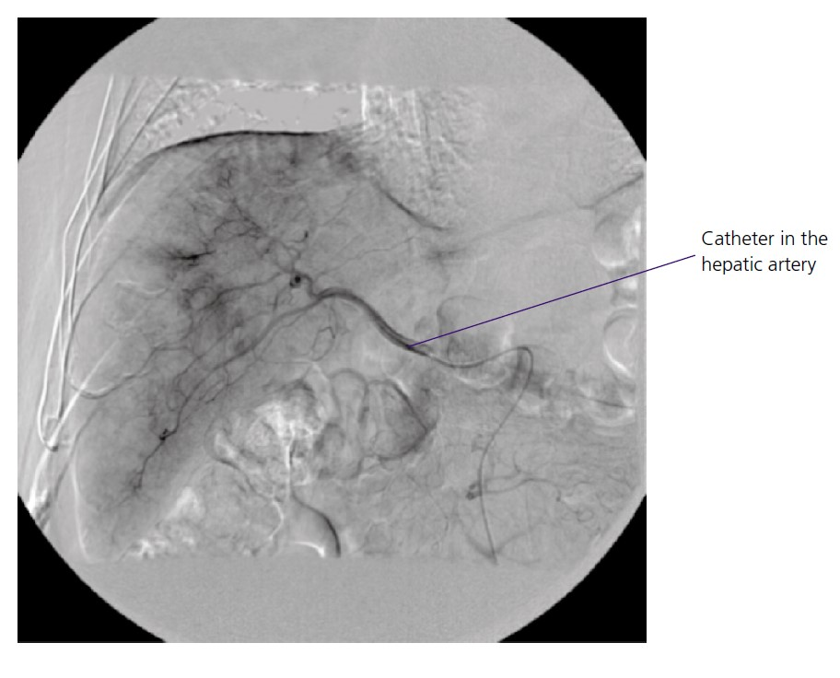
Hepatic arteriography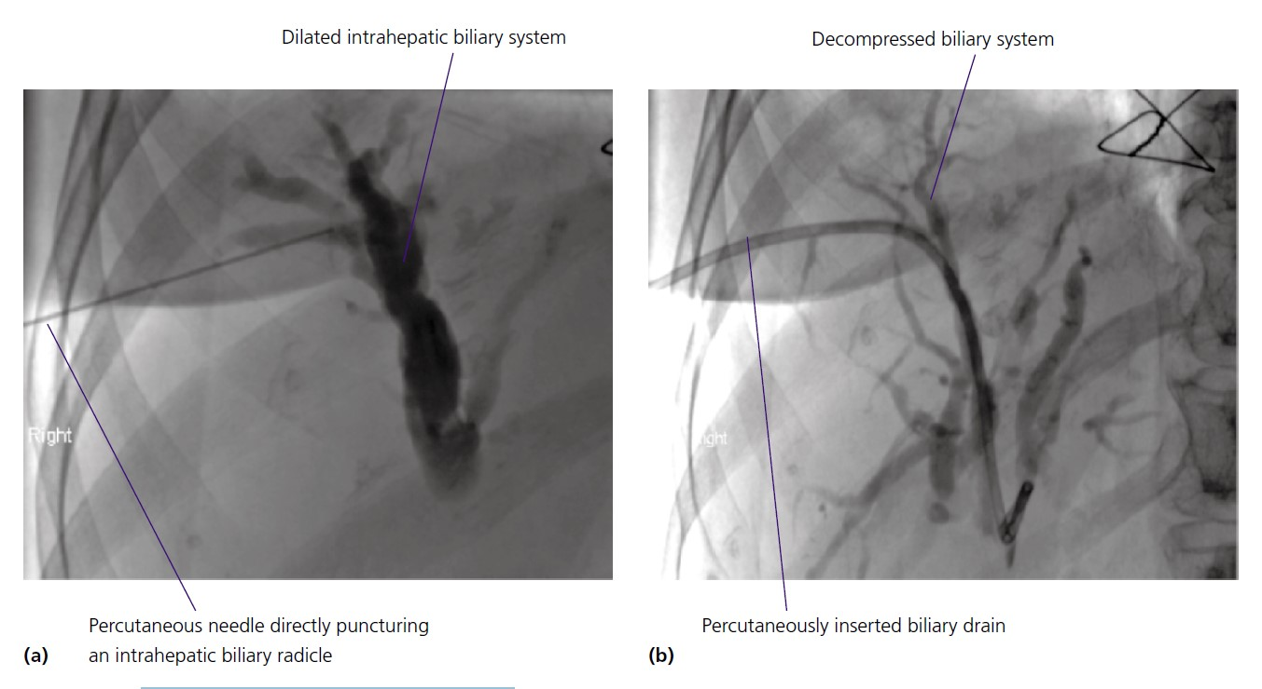

Histology and liver biopsy
Histological analysis is an important diagnostic tool for assessing liver disease. The method for obtaining a liver biopsy can vary from the transabdominal approach, transjugular approach, laparoscopic approach and open approach at operation or postmortem. The choice of route will depend on factors such as body habitus, clotting abnormalities, presence of ascites, available expertise and quantity of specimen required. Contraindications for the transabdominal approach are shown below:

Contraindications to percutaneous liver biopsy
• Coagulopathy. Biopsy not recommended if INR > 1.4 or platelets < 60 × 10 9 /L
• Dilated intrahepatic biliary system. Risk of bleeding into the biliary system (haemobilia)
• Marked ascites. Risk of uncontrolled bleeding into the ascites
• Cystic lesions. Risk of bleeding into cyst. Inadvertent biopsy of a hydatid cyst may result in anaphylaxis
• Severe emphysema. Risk of pneumothorax or bullous puncture leading to critical respiratory compromise
• Uncooperative patient. Patient needs to hold their breath during biopsy therefore cooperation is required
• Amyloidosis*. Increased risk of haemorrhage
• Bacterial cholangitis*. Risk of inducing peritonitis and septic shock
* Relative contraindications.

The biopsy delineates aetiology (e.g. viral hepatitis, alcoholic liver disease, metabolic liver disease, etc.), severity of disease (early fibrosis or cirrhosis) and specific pathological entities (e.g. steatosis or necroinflammation in non- alcoholic fatty liver disease).
Liver biopsy does have its limitations and some have questioned whether it truly represents a ‘ gold standard ’ reference test. In large studies of patients undergoing biopsy, pain has been reported in 20% and severe complications reported in 0.57%. Sampling error exists, which is unsurprising considering the average biopsy specimen represents 1/50 000th of the organ.
Interpretation of the biopsy is open both to intra - and interobserver error.
Non - invasive markers of liver fibrosis
The liver biopsy, when performed and analysed by specialists, represents a very useful tool to defi ne aetiology and delineate specific pathology including steatosis, necroinflammation and fibrosis. However, the rising prevalence of liver disease in association with patient choice, ethical implications of an invasive diagnostic test and economic considerations have led to the development of non - invasive tests of liver fibrosis. These have been utilised in clinical research but they are starting to emerge in clinical practice. The tests can be
divided into three broad areas:
1 Serum panel marker tests using routine clinical parameters (e.g. platelet count, AST : ALT ratio and albumin) or markers of fibrogenesis (e.g. hyaluronic acid, metalloproteases, serum type III procollagen peptide (PIII NP), etc.) or a combination.
2 Imaging modalities such as fibroscan (which measures the speed of a propagated wave across the liver using a specially adapted ultrasound device) and variants of MRI (e.g. MR spectroscopy and MR elastography).
3 High through put ‘ omics ’ technologies (e.g. proteomics).

